**SHIVAJI UNIVERSITY, KOLHAPUR**

**A**

**Project Report**

**ON**

**“FOUR LEGGED ROBOT”**

Submitted in partial fulfillment of the requirement for the degree of

**Bachelor of Technology**

**In**

**MECHANICAL ENGINEERING**

By

Raunak Nandkumar More

**Under the Guidance of**

**PROF. L. S. NIKAM**

**Department of Mechanical Engineering,**

**Department of Technology,**

**Shivaji University, Kolhapur**

**Maharashtra State, India.**

**2018 - 19**

**Department of Technology**

**Shivaji University, Kolhapur**

Maharashtra State, India

**CERTIFICATE**

This is to certify that,

Mr. MORE RAUNAK NANDKUMAR (213154)

studying in Final Year Mechanical has successfully completed the project entitled

**“FOUR LEGGED ROBOT”**

under the guidance and supervision of Prof. Name of the Guide during the academic year 2018 - 19. This is a part of partial fulfillment of the requirement for submission .

SHIVAJI UNIVERSITY, KOLHAPUR.

|  |  |
| --- | --- |
| **Prof. L. S. Nikam**  Guide  Dept. of Mechanical Engineering,  Department of Technology, | **Dr. A. B. Kolekar**  Coordinator,  Dept. of Mechanical Engineering,  Department of Technology, |
| **Dr. J. S.Bagi**  Director,  Department of Technology,  Shivaji University, Kolhapur | **Examiner** |

**ACKNOWLEDGEMENT**

We would like to express our deep and sincere gratitude to my Guide **Prof. L. S. Nikam**  Department of Mechanical Engineering, for guiding us to accomplish this project work. It was our privilege and pleasure to work under her able guidance. We are indeed grateful to her for providing helpful suggestions, from time to time. Due to her constant encouragement and inspiration we are able to present this project.

We express our deep gratitude to **Dr. A. B. Kolekar** of Mechanical Engineering, for his valuable guidance and constant encouragement. We are very much thankful to **Dr. J. S, Bagi** ,Director , Department of Technology, Shivaji University, Kolhapur for providing all the necessary facilities to carry out project work.

Last but not least we are thankful to our parents for their moral as well as financial support.

**ABSTRACT**

Less than half the Earth's landmass is accessible to existing wheeled and tracked vehicles. But people and animals using their legs can go almost anywhere. Our mission is to develop a new breed of rough-terrain robots that capture the mobility, autonomy and speed of living creatures. Such robots will travel in outdoor terrain that is too steep, rutted, rocky, wet, muddy, and snowy for conventional vehicles. Legged robots offer the potential to navigate highly challenging terrain .This report contains the use of Creep Gait to navigate through smooth to moderately rough surfaces .The robot is dynamically stable at all instances, meaning it is stable in every position. The application of such a robot is proposed to be used for mass data retrieval .This project aims at providing a novel design of the traditional spider’s leg and its adaptation in a quadruped robot and a different body structure than existing robots today.

**INDEX**

|  |  |  |  |
| --- | --- | --- | --- |
|  |  |  |  |
|  | **1** |  |  | **Introduction** | **1** |
|  |  | 1.1 |  | Background | 1 |
|  |  | 1.2 |  | Spider Robot |  |
|  |  | 1.3 |  | Motivation |  |
|  |  | 1.4 |  | Objective |  |
|  |  | 1.5  1.6 |  | Scope of work  Advantages |  |
|  | **2** |  |  | **Design, Mechanism and Fabrication** |  |
|  |  | 2.1  2.2  2.3  2.4  2.5 | 2.1.1  2.1.2  2.1.3  2.1.4  2.1.5  2.2.1  2.3.1  2.3.2 | Design  Mechanical Design Aspect  Electrical Design Aspect  Computer Science Design Aspect  Simplified Code Explanation  Diversion from traditional Coding  Mechanism  The Walking : Creep Gait  Fabrication  Electric Components  3D Printing  Finishing Operations  Experimental Set Up |  |
|  |  |  |  |  |  |
|  |  |  |  |  |  |
|  | **3**  **4**  **5** |  | 4.1  4.2  5.1  5.2 | **Assembly And Testing**  **Results And Discussion**  Results  Limitations  **Conclusions**  Conclusion  Future Scope  **REFERENCES** |  |
|  |  |  |  |  |  |
|  |  |  |  |  |  |
|  |  |  |  |  |  |

**List of Figures**

|  |  |
| --- | --- |
| **Fig No.** | **Name of the Figure** |
| 2.1 | Anatomy of spider leg |
| 2.2 | Angle of rotation of each part |
| 2.3 | Visual representation of planes |
| 2.4 | Division points for F.B.D. |
| 2.5 | Dimensions of a leg |
| 2.6 | F.B.D. of Tibia |
| 2.7 | C.O.G. of Tibia |
| 2.8 | F.B.D. for Femur |
| 2.9 | C.O.G. of Tibia – Femur Assembly |
| 2.10 | F.B.D. for Coxa |
| 2.11 | C.O.G. for Tibia-Femur-Coxa Assembly |
| 2.12 | General electric layout |
| 2.13 | Schematics of Bluetooth module |
| 2.14 | Schematics of arduino pro mini |
| 2.15 | Schematics of I2C modules |
| 2.16 | Schematics of extra slots |
| 2.17 | Schematics of high efficiency LM2596 step down module |
| 2.18 | Schematics of servo’s position |
| 2.19 | Actual PCB layout |
| 2.20 | Leg Position |
| 2.21 | Positions in Gait |
| 2.22 | Leg positions |
| 2.23 | Breaking down the mechanism |
| 2.24 | Break Down of the Creep Gait |

**List of Images**

|  |  |
| --- | --- |
| **Img. No.** | **Name of the Image** |
| 2.1 | Calibration chart |
| 2.2 | PCB |
| 2.3 | 12 V Mini Solder |
| 2.4 | Setting LM2596 to 5V output |
| 2.5 | Arduino Pro Mini 5V ,16 MHz |
| 2.6 | PCB after soldering |
| 2.7 | Final Electric System |
| 2.8 | Raise3D’s N2 V2 Hot End |
| 2.9 | 3D Settings |
| 2.10 | Some Errors while printing |
| 2.11 | Chassis in Print |
| 2.12 | Burr Removal in Servo’s Gear Box |
| 2.13 | Support Removal |
| 2.14 | Filing Operation |
| 2.15 | Lubricating Meshing Parts |
| 2.16 | Experimental set-up |
| 3.1 | Inserting Servos In between Parts |
| 3.2 | After Servo Insertion |
| 3.3 | Different types of Servo Arm Rockers |
| 3.4 | Assembly of First Leg |
| 3.5 | Calibration in Process |
| 3.6 | Calibration Position |
| 3.7 | Calibrated Position |
| 3.8 | Right Hand Side View |
| 3.9 | Bottom Hand Side View |
| 3.10 | Left Hand Side View |

**CHAPTER 1**

# INTRODUCTION

* 1. **Background**

Robotics is the branch of engineering science & Technology related to robots, and their design, manufacture, application, and structural disposition. Robotics is related to electronics, mechanics, and software. Robotics research today is focused on developing systems that exhibit modularity, flexibility, redundancy, fault-tolerance, a general and extensible software environment and seamless connectivity to other machines, some researchers focus on completely automating a manufacturing process or a task, by providing sensor based intelligence to the robot arm, while others try to solidify the analytical foundations on which many of the basic concepts in robotics are built. In this highly developing society time and man power are critical constrains for completion of task in large scales. The automation is playing important role to save human efforts in most of the regular and frequently carried works. One of the major and most commonly performed works is picking and placing of jobs from source to destination. Present day industry is increasingly turning towards computer-based automation mainly due to the need for increased productivity and delivery of end products with uniform quality. The inflexibility and generally high cost of hard-automation systems, which have been used for automated manufacturing tasks in the past, have led to a broad based interest in the use of robots capable of performing a variety of manufacturing functions in a flexible environment and at lower costs. The use of Industrial Robots characterizes some of contemporary trends in automation of the manufacturing process. However, present day industrial robots also exhibit a monolithic mechanical structure and closed-system software architecture. They are concentrated on simple repetitive tasks, which tend not to require high precision. The pick and place robot is a microcontroller based mechatronic system that detects the object, picks that object from source location and places at desired location. For detection of object, infrared sensors are used which detect presence of object as the transmitter to receiver path for infrared sensor is interrupted by placed object.Use center alignment for the figures and photos.

* 1. **Spider Robot**

What Is a "Spider Robot?"

As its name defines it, our robot is a basic representation of the spider movements but it will not perform exactly the same body moves since we are using only four legs instead of eight legs.It has 3 Degrees of Freedom for each leg with 4 legs making a total of 12 DOFs.

Legged robotics is a continuously growing technology with more attention focused on dynamic control of such robots during locomotion. With better understanding of legged locomotion and movement capabilities, motion algorithms can be improved to mimic more natural dynamic movement modeled after animal gait patterns. Eventually, as movement capabilities of legged robot advance, so will their applications in various fields. Their abilities can be expanded to rescue operations, unmanned exploration like mines, pack-mules, and military operations like bomb defusal,mine detection or under radar surveillance. In order to improve and quantify motions, an appropriate platform that can support movements such as crawling, walking, running, and jumping must be built. Before designing and producing a robot platform, the behaviors and motions of legged robot counterparts , i.e. 4 legged animals and spider must be understood. Four legs are the minimum legs required for a robot to walk with a statically stable gait. That is, a gait pattern where there are enough contact points to prevent a tipping moment with the robot body. Quadrupeds produce a triangular support polygon during their stable gait patterns

Legged robots handle terrain better than their wheeled counterparts and move in varied and animalistic ways. However, this makes legged robots more complicated, and less accessible to many makers. and also the making cost and the high expenses that a maker should spend in order to create a full body since it is based on servo motors or stepper motors and both are more expensive than DC motors that could be used in wheeled robots.

* 1. **Motivation**

Legged robots or vehicles can navigate on any kind of surfaces which is inaccessible for robots with wheels. In the previous section, we discussed different kinds of wheels for different surfaces, but no standard works on all surfaces. Also, wheels are designed to work on prepared surfaces like smooth surfaces, roads, rails, etc.

• Legged robots can jump or step over obstacles whereas wheels need to somehow travel over it, or take a different path.

• Wheels require a continuous path to travel whereas legs can step over isolated paths and move on. For example, if a particular city is hit by an earthquake, then the surface with a continuous path. This is where legged robots come into picture, although tracked wheels can manage up to a “certain” extent.

• Legged robots can avoid undesirable footholds which cannot be avoided in a wheeled robot

• Legged robot helps us in exploring human and animal locomotion

• Once we move off from our modified habitat into rough, rocky, sandy, steep and undesired terrain, we understand that our brilliant invention of wheels turn out absolutely useless

• Lastly, the excitement of replicating a human or an animal and try to challenge nature (Biomimatics)

* 1. **Objective**
* To create a Proof of Concept robot that is able to explore environments unsafe for humans such as in case of fires,chemical leaks,hazardous atmospheric areas,radiation prone zones
* To create a robot that could send us information regarding these areas where aerial robots are inaccessible
* To create an alternate terrestrial robot design that does not use wheel or chain drives assemblies
* Walking with four legs is common for most animals and there is a good reason to replicate this in robots. Four legged robots are statically stable and the walking pattern of a four legged robot can be designed in different ways:
* One leg at a time: At any point there are three contact points to surface and the robot maintains static stability while standing or moving. Moving one leg at a time makes your robot slower and expensive on the resources, but keeps it stable.
* Alternating Pair: In this approach, alternate legs are moved as if two biped robots are connected together. At any time the robot has two surface contact points creating a dynamically stable robot. Faster and efficient, but less stable compared to the first approach.
* Our objective was to design it for a one leg at a time or creep gait
  1. **Scope of work**

The progress in legged dynamics of robots has reached to such a level where they can sucessfully tread anywhere;be it rugged terrene,sand dunes,muddy lands,marshes,etc.Locomotion on these different landscapes requires usage of multiple and complex gaits.However , the scope of our work is limited to locomotion on moderately even surfaces with the most stable gait ,the Creep Gait.Also the communication interface is using bluetooth thus the range on sucessful operation is 50m.Project is limited to traditional logic coding to actuate servos via softwares and no machine learning is been used.The scope of work strictly limits to creating a robot that is statically stable at all instants of time and the movements are looped,meaning each command ends results in the respective action been executed completely.

* 1. **Advantages**

Quadruped robots have a large number of real life applications, from crossing potentially dangerous terrain to carrying out search and rescue operations in hazardous and unpredictable disaster zones (Karalarli, 2003). They have a number of advantages over wheeled, quadruped or bipedal robots:

1. While wheeled robots are faster on level ground than legged robots, quadruped are the fastest of the legged robots, as they have the optimum number of legs for walking speed - studies have shown that a larger number of legs does not increase walking speed.

• Quadruped are also superior to wheeled robots because wheeled robots need a continuous, even and most often a pre-constructed path. Quadruped robots however can traverse uneven ground, step over obstacles and choose footholds to maximise stability and traction.

• Having maneuverable legs allows Quadruped robots to turn around on the spot .

• In comparison to other multi-legged robots, quadruped robots have a higher degree of stability as there are can be up to 5 legs in contact with the ground during walking. Also, the robots center of mass stays consistently within the tripod created by the leg movements, which also gives great stability (Mushrush & Spirito, 1978).

• Quadruped also shows robustness, because leg faults or loss can be managed by changing the walking mechanism (Ding et al, 2010).

• This redundancy of legs also makes it possible to use one or more legs as hands to perform dexterous tasks.

• You will find quadrupeds abundant in nature,that is animals, because four legs allow for passive stability, or the ability to stay standing without actively adjusting position. The same is true of robots. A four-legged robot is cheaper and simpler than a robot with more legs, yet it can still achieve stability.

•Because of all of these benefits, quadruped robots are becoming more and more common, and it will be interesting to see what modifications roboticists come up with to further improve and develop their form and function.

**CHAPTER 2**

# DESIGN, MECHANISM AND FABRICATION

This Chapter will include indepth description of the stepwise development of the project.Design softwares use include CAD softwares like SketchUp 2019 Pro Edition for parts modelling,EAGLE 9.2.0 for modelling of Printed Circuit board,CAM(Slicer) software like Raise3D’s ideaMaker x64 3.1.7.We have also used 3rd Party Extensions like FredoCorners,SolidTools,Merger and SolidView to facilitate part modelling.Force Analysis has been done manually and the parts have been made durable enough to sustain dynamic and static loading via trial and error,as 3D printed parts have hollowed out parts,randomly generated by slicer softwares thus eliminating the need for stress analysis.The open-source Arduino Software (IDE) makes it easy to write code and upload it to the board. It runs on Windows, Mac OS X, and Linux. The environment is written in Java and based on Processing and other open-source software. This is where you type the code you want to compile and send to the arduino board. The Intial Setup: We need to setup thee environment to the Tools menu and select Board Then select the type of Arduino you want to program,in our case it’s Arduino The code you write for your Arduino are known as sketches. They are written in c++. The Drivers used for COM port for uploading of code are PL2303 Prolific DriverInstaller v1.8.0

* 1. **Design**

The Design Process will be divided into 4 major parts:

* Mechanical Design Aspect
* Electrical Design Aspect
* Computer Science Design Aspect
* Corrective Design Post Fabrication
  + 1. **Mechanical Design Aspect**

In order to understand the behaviors of a quadruped robot under certain static and dynamic situations, rigid body analysis of the robot were conducted.

For the analysis the following assumptions were made:

All four legs are identical, linkages have evenly distributed masses, contact with the ground occurs at a point actuators have negligible mass, and all motions are planar.

First, mechanical analysis of a single leg was conducted before the quadruped robot was analyzed as a whole. Since all four legs are identical, the forces and torques present in one leg are similar in the other three legs.

The analysis will majorly be done by FBDs at all 3 servo motors of a leg.The design for the leg was chosen with reference to actual leg of a spider.As actual spider consisted of multiple parts discussed below,we had to remove some parts for simplicity.

* + 1. **Anatomy of a Spider and its adaptation in our robot**

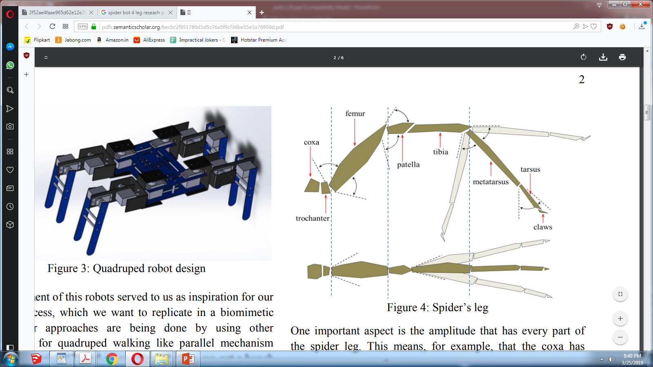

**Fig.2.1 Anatomy of spider leg**

Initially, it’s important to know that the spider has 7 parts byleg. These parts are: coxa, trochanter, femur, patella,tibia, metatarsus and tarsus. This spatial arrangement it’s illustrated in the figure 4. From the original anatomy of the spider, we suppress some components which we didn’t need.The reason of this it’s because we wanted to simplify the whole system. Having said this, instead of using the Patella part, we linked the femur and the tibia by a direct joint. The metatarsus and the tibia were united as a single link or part. Similarly, we dismiss the tarsus. All of these dismissals were executed in the robot, but for the kinematics we took account the entirely system for a realistic approach and because we wanted to know what exactly we were suppressing.

One important aspect is the amplitude that has every part of the spider leg. This means, for example, that the coxa hasamplitude of 35 degrees while tibia has a mobility of 70degrees. Also, every of the seven components of the limb, hasa different axis of movement; for example, the trochanter has amovement in X-Y axis, meanwhile the femur in X-Z axis.This kind of association and motion, it’s explained graphicallyin the following figure.

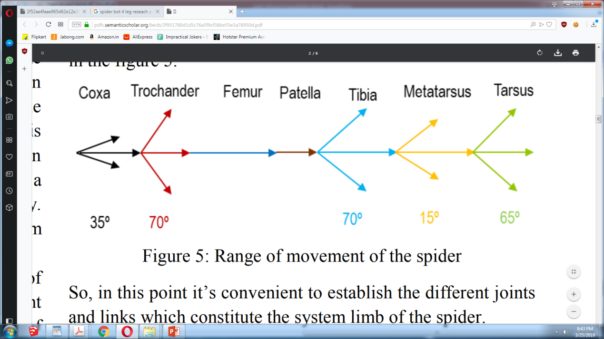

**Fig.2.2 Angle of rotation of each part**

So, in this point it’s convenient to establish the different jointsand links which constitute the system limb of the spider.

• Body-Coxa joint: Some authors view this joint as a threedegrees of freedom (DOFs) ball-and-socket joint.

• Coxa-Trochanter joint: Some individuals view this joint as,either a 3-DOFs ball-and-socket or a 2-DOFs saddle joint.

• Trochanter-Femur joint: this joint can be modeled as auniversal joint with 2-DOFs.

• Femur-Patella joint: Commonly this joint can be modeledas a hinge joint.

• Patella-Tibia joint: There are two options to model thisjoint; first as a hinge joint or a universal joint with verylimited joint on Y-Z axis.

• Tibia-Metatarsus: it is also possible to assume this joint asa hinge joint, or a universal joint but with some constraints.

• Metatarsus-Tarsus joint: this joint can be modeled as auniversal joint.

In this case, the claws are the end-effector of the system. Thismeans that this part of the limb is whom interacts with theoutside .

As we mentioned previously, there are some constraints thatwe applied in the anatomic development. We applied thesemodifications in the mathematical development and wedecided to involve all the possible variables, based on thefollowing table to produces the most faithful model andprototype.

The Following parts were accepted in the final draft.Angles of movement and their rotaion axii are defined below,and we have tried to use the same definations in our robot,i.e. the shape of leg as far as possible.

|  |  |  |
| --- | --- | --- |
| PARTS | ROTATION(in degrees) | PLANE |
| Coxa | 75 | Transversal |
| Femur | 140 | Sagittal |
| Tibia | 40 | Sagittal |

**Table 2.1 Part specifications**

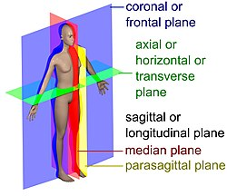

**Fig.2.3 Visual representation of planes**

* + 1. **Limiting Torque Calculations and validation of Mechanical Design**

The major torque calculations are based at servomotor shafts as their torque limits are the limiting factors that determine whether the machine performs its functions or not.The torque calculations are done by constructing FBD’s at each servo of a leg.An acceptable design is that in which the resisting torque of servos is more than required torque for its movement and stay position

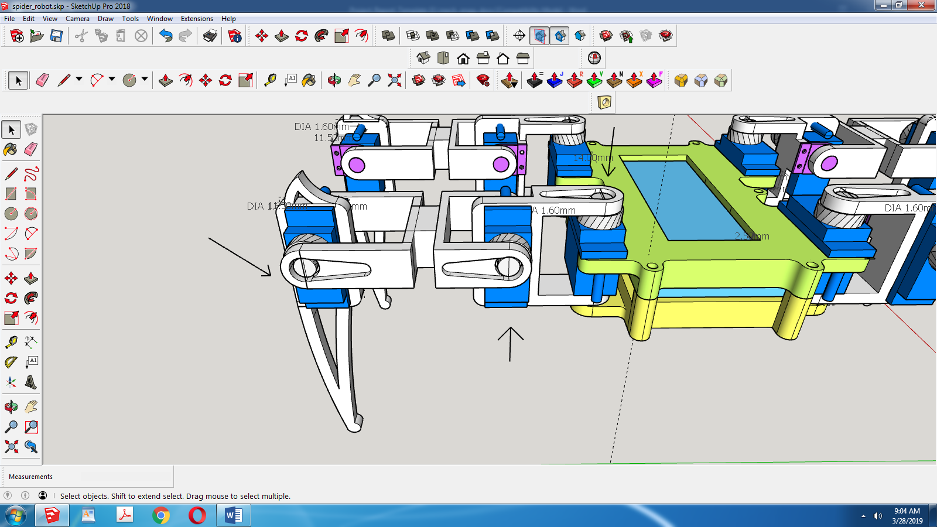

**Fig.2.4 Division points for F.B.D. .**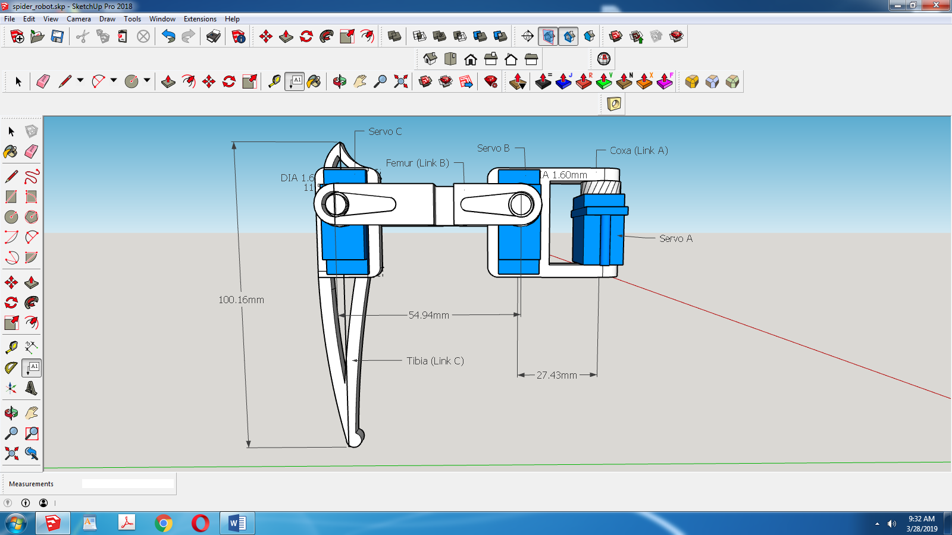

**Fig.2.5 Dimensions of a leg**

Coxa with length 27.43mm and called link A with Servo A

Femur with length 54.94mm and callled link B with Servo B

Tibia with length 100mm and called link C with Servo C

Tibia Calculations

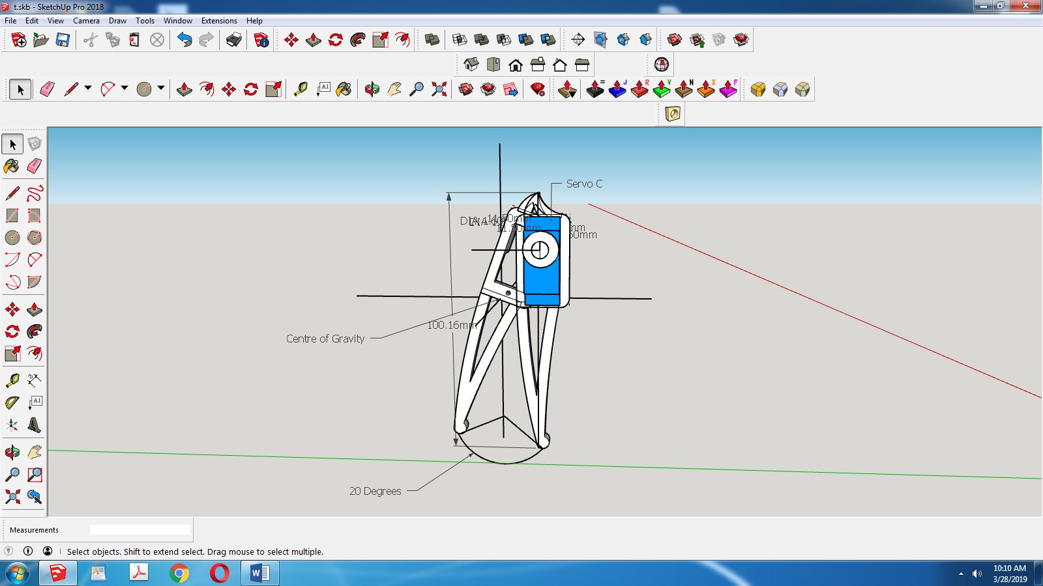

**Fig.2.6 F.B.D. of Tibia**

As stated before tibia moves 40 Degrees to either sides.Thus Max torque required is when tibia moves at 20 Degrees to either sides with outer side adding max to torque requirements.

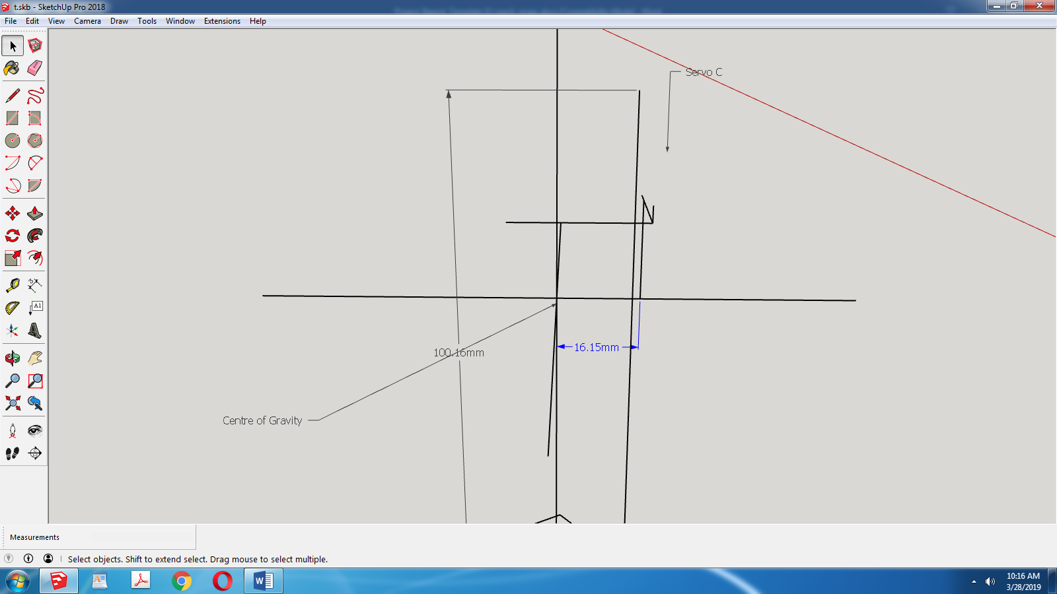

**Fig.2.7 C.O.G. of Tibia**

Thus Tibia’s COG lies 16.15 mm away from servo C.

Torque C = 1.5kg-cm = 1.615cm x Limiting Reaction at End Effector

Limiting Reaction at End Effector Point = 0.928 kg

Femur Calculations

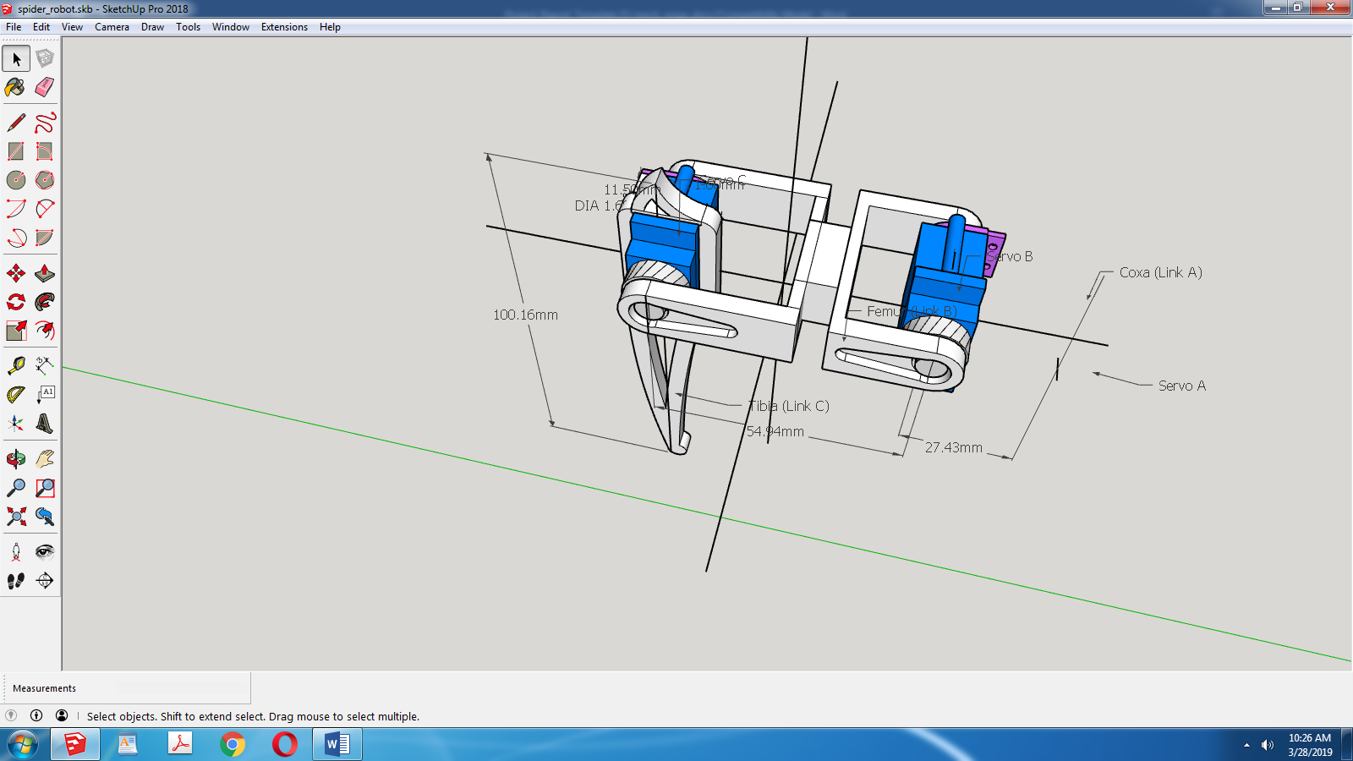

**Fig.2.8 F.B.D. for Femur**

For Femur’s Servo B, We construct FBD for left hand side of the leg and apply Reaction at end effector or leg ground contact point in vertically upward direction.COG for whole assembly including the servo B itself.

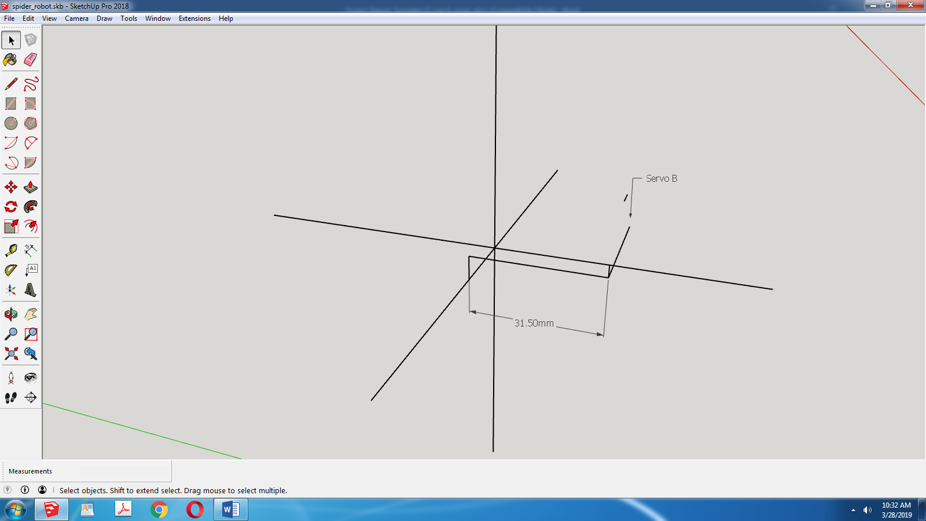

**Fig.2.9 C.O.G. of Tibia – Femur Assembly**

Torque B = 1.5kg-cm= Limiting Reaction at End Effector Point x 3.15cm

Limiting Reaction at End Effector Point = 0.476 kg

Coxa Calculations

Coxa’s Torque calculations do not matter much as its movement does not put load on Servo.The load is supported by the body itself and the servo A’s Function is to support the leg weight in space and to push the 1/4th total weight in x direction .

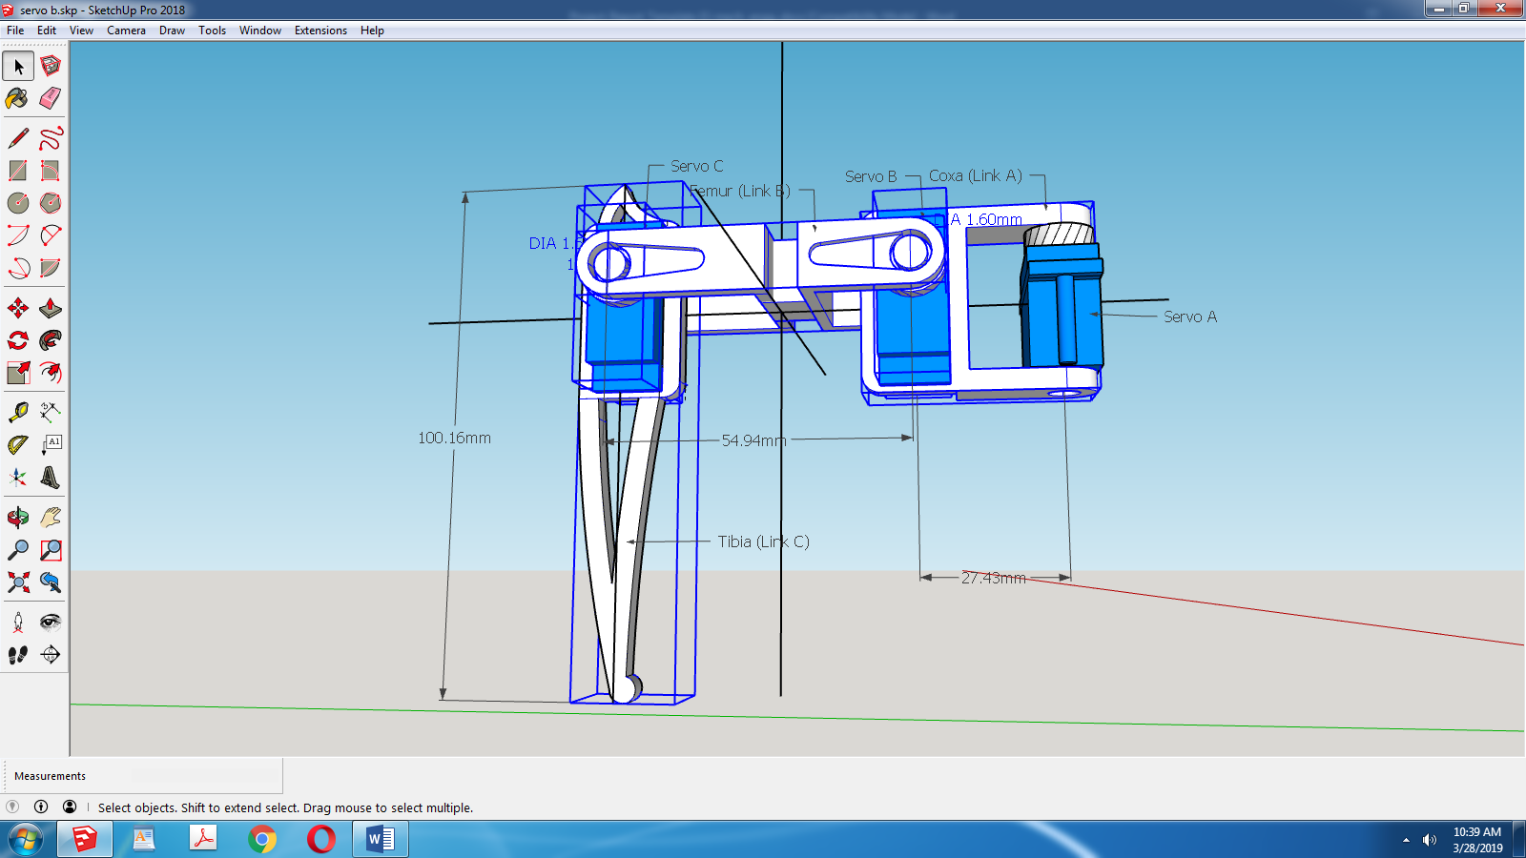

**Fig.2.10 F.B.D. for Coxa**

It should be particularly noted that the self weight of servo A is not to be considered in COG calculations as it is supported by central body and not the leg.

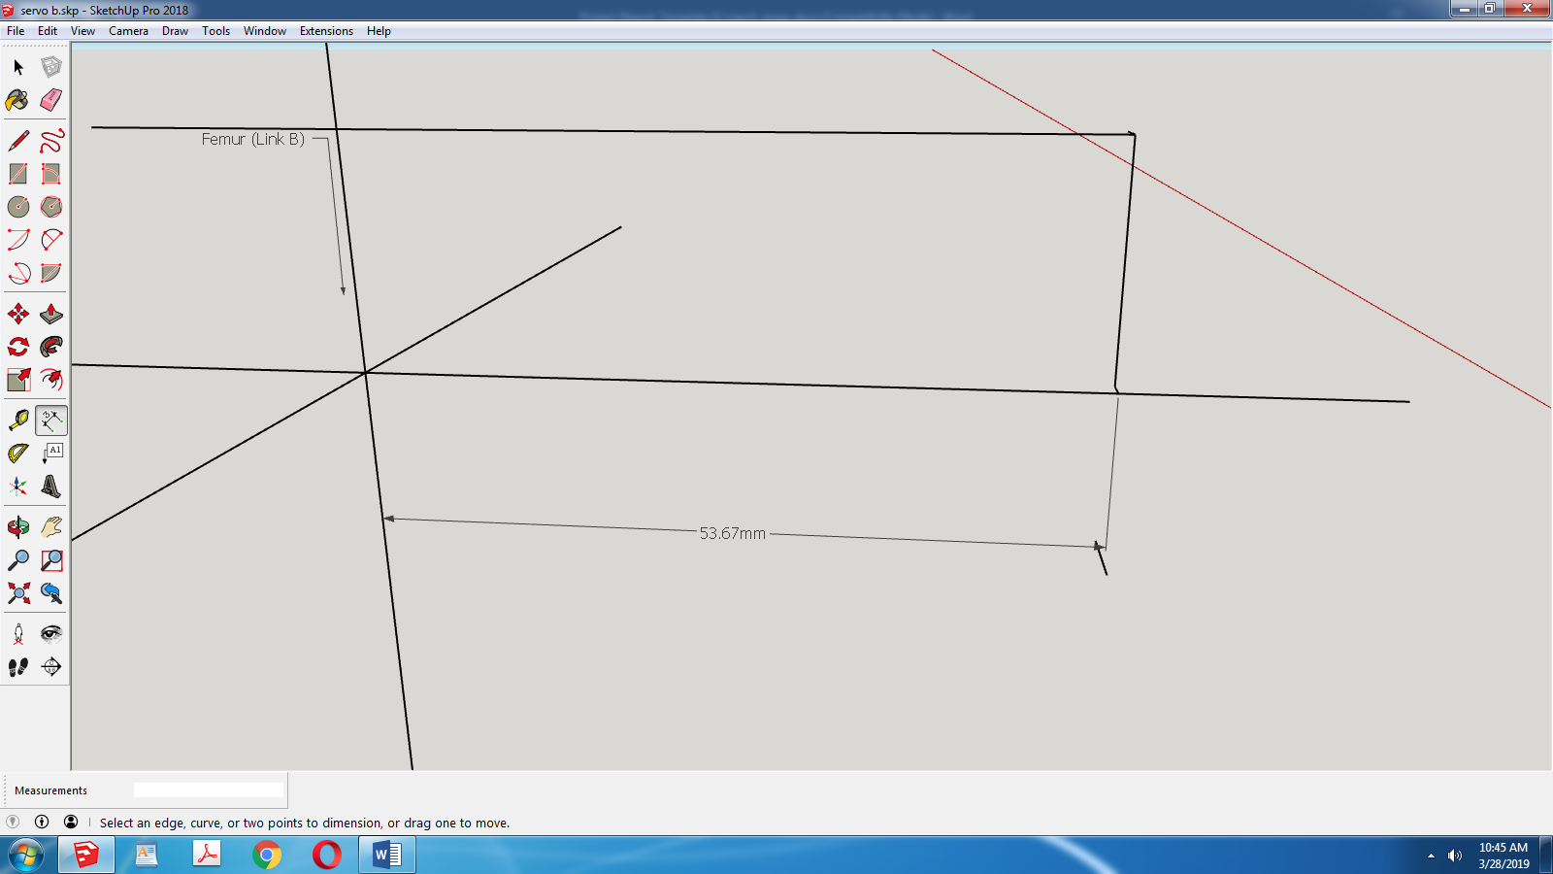

**Fig.2.11 C.O.G. for Tibia-Femur-Coxa Assembly**

Torque C =1.5= 5.367 x Limiting Reaction at End Effector Point

Limiting Reaction at End Effector Point =0.279kg

From all 3 of above calculations it can be seen that Limiting Reaction at End Effector Point is well below the actual Reaction at End Effector Point which is the toal weigth of machine/4 = 0.281/4 kg = 0.07025 kg

Thus our Mechanical design is validated.It is to be noted that we have not calculated exact torque required for operation.This is done due to the assumtions underlying these calculations where COG have been calculate taking into account uniform density of all parts which is not the cse since the servos have vacancies in then and their internal parts are made of different density materials.Thus our design uses a Factor of Safety greater than 4 to be on the safer side.Optimising the design can also be one of the future scopes

* + 1. **Electrical Design Aspect**

**2.1.2.1 Servo Motors Are the Main Actuators**

A servomotor as defined is a rotary actuator or linear actuator that allows for precise control of angular or linear position, velocity and acceleration.It consists of a suitable motor coupled to a sensor for position feedback. It also requires a relatively sophisticated controller, majorly known as a servo controller ,often a dedicated module designed specifically for use with servomotors.

Servomotors are not a specific class of motor although the term servomotor is often used to refer to a motor suitable for use in a closed-loop control system.

Generally speaking the control signal is a square wave pulse train. Common frequencies for control signals are 44Hz, 50Hz, and 400Hz. The positive pulse width is what determines the servo position. A positive pulse width of around 0.5ms will cause the servo horn to deflect as much as it can to the left (generally around 45 to 90 degrees depending upon the servo in question). A positive pulse width of around 2.5ms to 3.0ms will cause the servo to deflect to the right as far as it can. A pulse width of around 1.5ms will cause the servo to hold the neutral position at 0 degrees. The output high voltage is generally something between 2.5 volts and 10 volts (with 3V typical). The output low voltage ranges from -40mV to 0V.

**2.1.2.2 General Layout**



**Fig.2.12. General electric layout**

The above figure outcases the general logic of electric system while the below figure shows schematics.The general flow of power is as such:

Battery DC jack DC-DC Converter Switch Arduino Pro Mini

Resistance LED 12 Servo motors

**2.1.2.3 Actual Schematics**

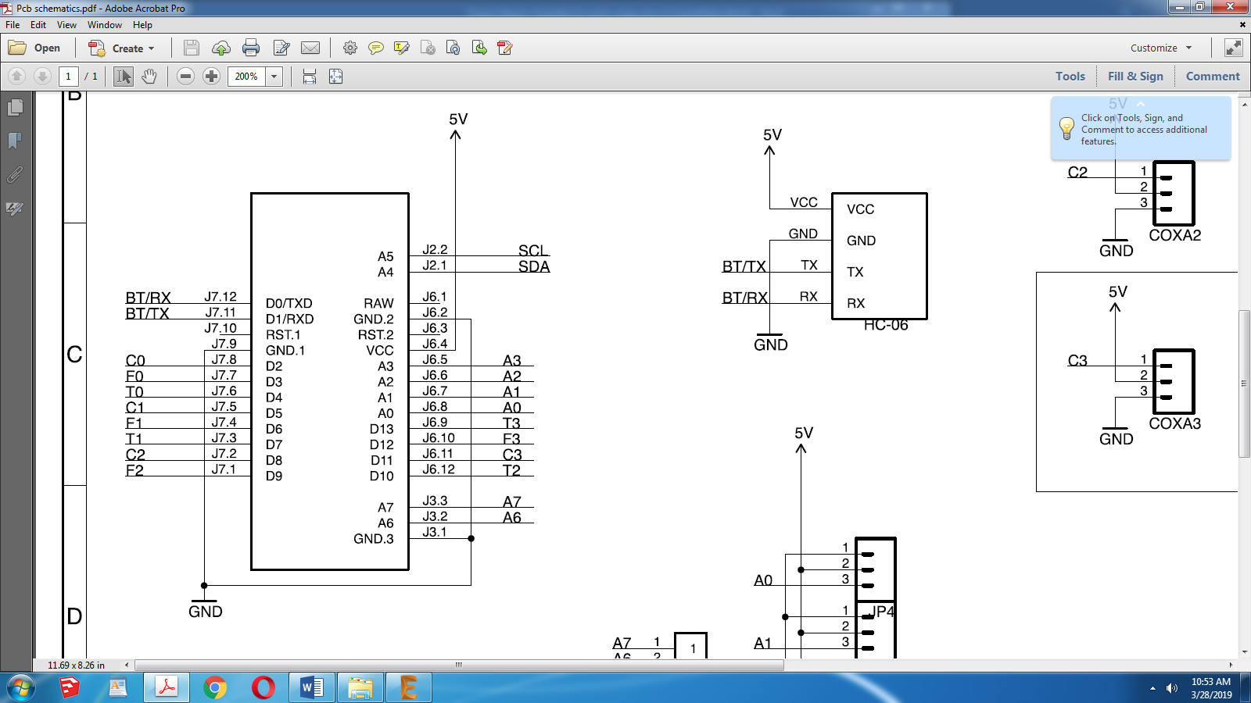

**Fig.2.13. Schematics of Bluetooth module**

Above is a Bluetooth HC-06 Module,and its connections to Arduino Pro Mini via interchanged TX RX pins



**Fig.2.14. Schematics of arduino pro mini**

Above shows Connections of various parts to our Main Board Arduino Pro Mini

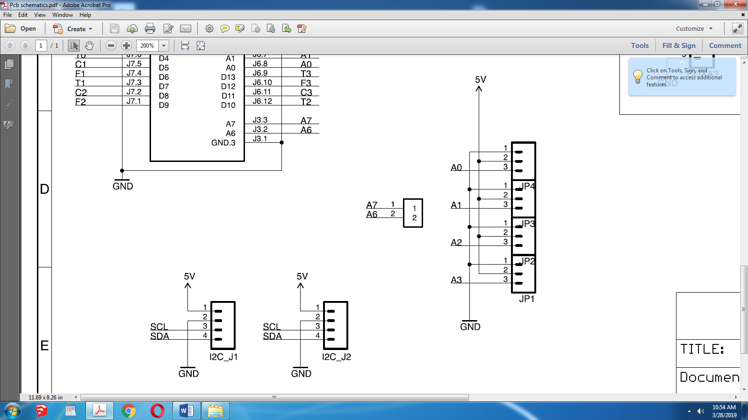

**Fig.2.15. Schematics of I2C modules**

Above shows Addition of 2 I2C junctions onto PCB for Sensors,Stacking or Displays



**Fig.2.16. Schematics of extra slots**

4 more ports added to facilitate a 5th Limb addition or any sensors

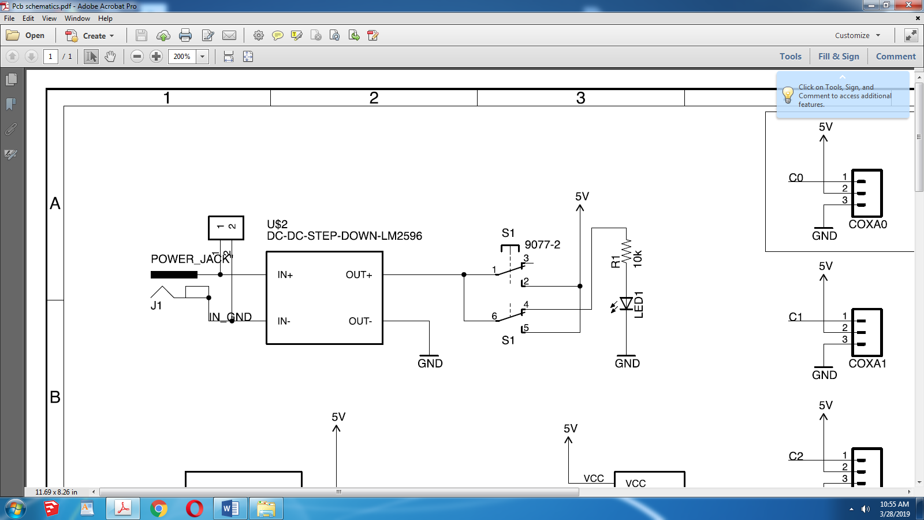

**Fig.2.17.** **Schematics of high efficiency LM2596 step down module**

Shows the LM2596 Step down DC to DC module (97% efficiency) that converts 11.1V DC from Battery to 5V and the parrelel battery charge display circuit.

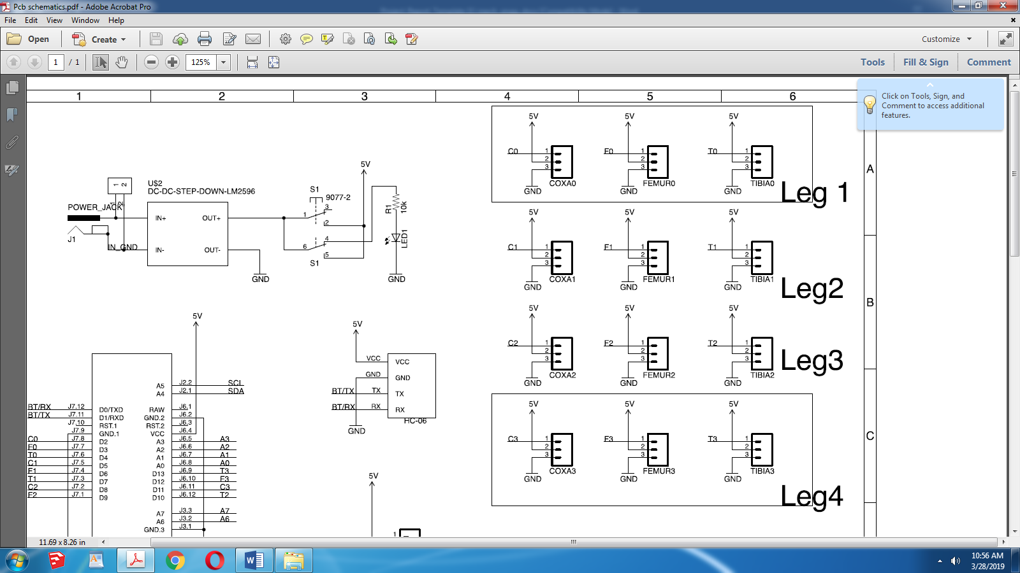

**Fig.2.18. Schematics of servo’s position**

Above figure shows connections of servo motors and their respective counter parts of legs

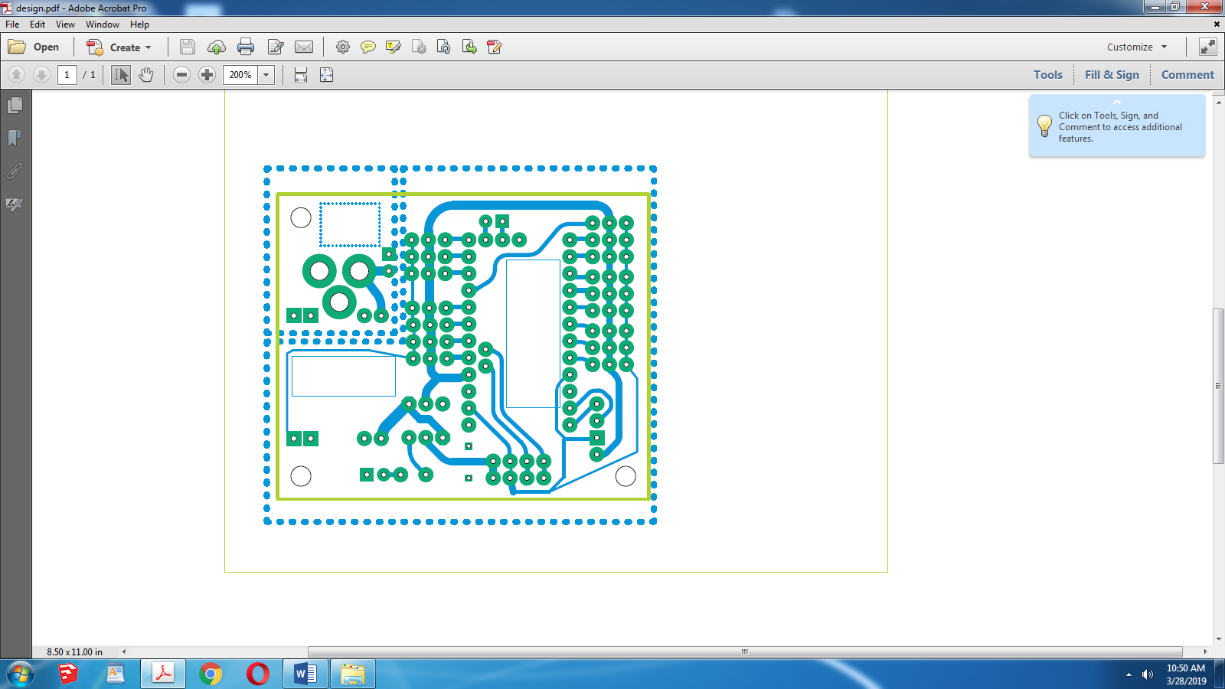

**Fig.2.19. Actual PCB layout**

The above figure shows actual pathway layout of the pcb.

* + 1. **Computer Science Design Aspect**
       1. **Simplified Code Explanation**

The first thing to do is decide the specific x,y positions of the legs at each position (Figure C).

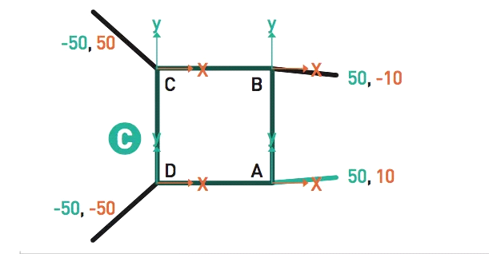

**Fig.2.20. Leg Position**

Each leg has its own x- and y-axis. We can give the foot of each leg a position, in millimeters, relative to that axis. For example, the top-left leg has the position (-50,50). Now we can apply these positions to each stage of the creep gait. Keep in mind that the specific positions you want will depend on the length of your robot’s leg. For any arbitrary quadruped, you will need to do some measuring to find the right numbers. Figure D is an example of the positions.

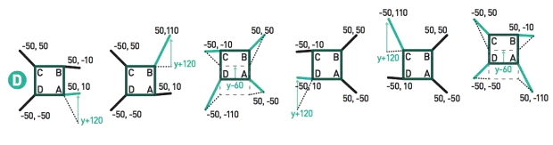

**Fig.2.21. Positions in Gait**

Between each step, we only need to deal with the change in position denoted by the green arrows on the sequence above. So how does this translate to code? Let’s take a look at the Arduino code to implement it

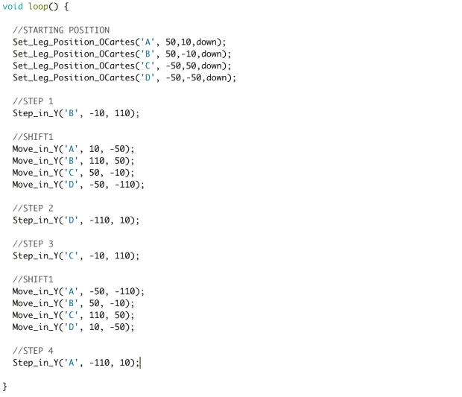

Let’s break it down further in Figures E through K.

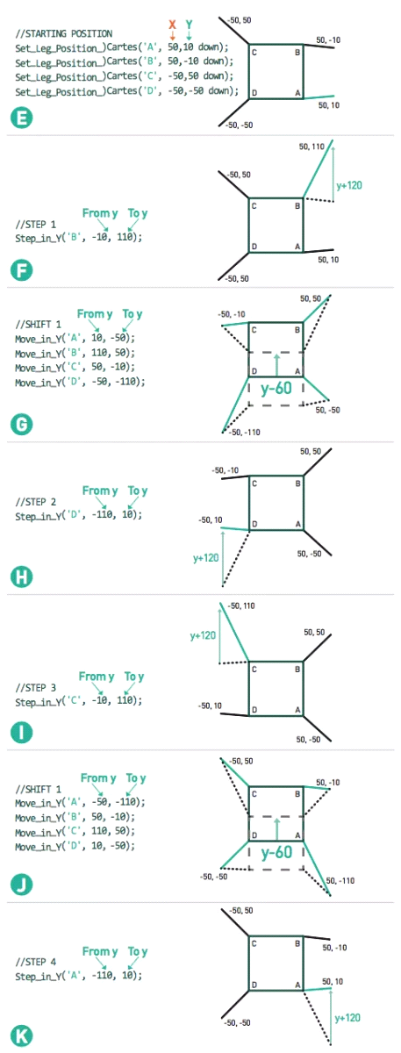

**2.1.3.2 Diversion from Traditional Coding , Simplifying the code further:**

Since we are using servomotors, we need to translate servomotor angles into the positions described here.However,since translating these angles into positions is a task requiring inverse kinematics whose solutions require high computing power and an understanding of complex mathematics,we have tried to limit our dependancy on traditional methods and simplified our methods with defining one stable position of the robot and manupulating the variables onto another position with multiple trials until an accepted forward motion is done;doing so means more time consumed than using inverse kinematics

**2.1.3.3 Actual Code and its Explanation**

* Overview

This version of the robot has 4 legs, and each leg is driven by 3 servos.

This robot is driven by a Ardunio Pro Mini with an expansion Board.

This project requires some library files, which you can find in the head of

this file. Make sure you have installed these files.

Before use,you must to adjust the robot,in order to make it more accurate.

- Adjustment operation

1.uncomment ADJUST, make and run

2.comment ADJUST, uncomment VERIFY

3.measure real sites and set to real_site[4][3], make and run

4.comment VERIFY, make and run

/* Includes ------------------------------------------------------------------*/

#include <Servo.h> //to define and control servos

#include <FlexiTimer2.h>//to set a timer to manage all servos

#include <EEPROM.h> //to save errors of all servos

#include <SerialCommand.h>

SerialCommand SCmd; // The demo SerialCommand object

/* Installation and Adjustment -----------------------------------------------*/

//#define INSTALL //uncomment only this to initate the robot

//#define ADJUST //uncomment only this to adjust the servos

//#define VERIFY //uncomment only this to verify the adjustment

const float adjust_site[3] = { 100, 80, 42 };

const float real_site[4][3] = { { 100, 85, 35 }, { 106, 85, 23 },

{ 105, 85, 27 }, { 106, 60, 35 } };

/* Servos --------------------------------------------------------------------*/

//define 12 servos for 4 legs,think of it as a initiation code to be called every boot

Servo servo[4][3];

//define servos' ports,defines which ports have which servo installed

const int servo_pin[4][3] = { {2, 3, 4}, {5, 6, 7}, {8, 9, 13}, {10, 11, 12 } };

/* Size of the robot ---------------------------------------------------------*/

const float length_a = 55;

const float length_b = 77.5;

const float length_c = 27.5;

const float length_side = 71;

const float z_absolute = -26;

/* Constants for movement ----------------------------------------------------*/

const float z_default = -50, z_up = -30, z_boot = z_absolute;

const float x_default = 62, x_offset = 0;

const float y_start = 0, y_step = 40;

const float y_default = x_default;

/* variables for movement ----------------------------------------------------*/

volatile float site_now[4][3]; //real-time coordinates of the end of each leg

volatile float site_expect[4][3]; //expected coordinates of the end of each leg

float temp_speed[4][3]; //each axis' speed, needs to be recalculated before each movement

float move_speed; //movement speed

float speed_multiple = 1; //movement speed multiple

const float spot_turn_speed = 6;

const float leg_move_speed = 8;

const float body_move_speed = 3;

const float stand_seat_speed = 1;

volatile int rest_counter; //+1/0.02s, for automatic rest

//functions' parameter

const float KEEP = 255;

//define PI for calculation

const float pi = 3.1415926;

/* Constants for turn --------------------------------------------------------*/

//temp length

const float temp_a = sqrt(pow(2 * x_default + length_side, 2) + pow(y_step, 2));

const float temp_b = 2 * (y_start + y_step) + length_side;

const float temp_c = sqrt(pow(2 * x_default + length_side, 2) + pow(2 * y_start + y_step + length_side, 2));

const float temp_alpha = acos((pow(temp_a, 2) + pow(temp_b, 2) - pow(temp_c, 2)) / 2 / temp_a / temp_b);

//site for turn

const float turn_x1 = (temp_a - length_side) / 2;

const float turn_y1 = y_start + y_step / 2;

const float turn_x0 = turn_x1 - temp_b * cos(temp_alpha);

const float turn_y0 = temp_b * sin(temp_alpha) - turn_y1 - length_side;

/*

- setup function

---------------------------------------------------------------------------*/

void setup()

{

/*#ifdef INSTALL

//initialize all servos

for (int i = 0; i < 4; i++)

{

for (int j = 0; j < 3; j++)

{

servo[i][j].attach(servo_pin[i][j]);

delay(100);

}

}

while (1);

#endif

#ifdef ADJUST

adjust();

while (1);

#endif

#ifdef VERIFY

verify();

while (1);

#endif

*/

//starting serial for debugging,and bluetooth connectivity

Serial.begin(9600);

Serial.println("Robot starts initialization");

// Setup callbacks for SerialCommand commands

// action command 0-6,

// w 0 1: stand

// w 0 0: sit

// w 1 x: forward x step

// w 2 x: back x step

// w 3 x: right turn x step

// w 4 x: left turn x step

// w 5 x: hand shake x times

// w 6 x: hand wave x times

SCmd.addCommand("w", action_cmd);

SCmd.setDefaultHandler(unrecognized);

//initialize default parameter

set_site(0, x_default - x_offset, y_start + y_step, z_boot);

set_site(1, x_default - x_offset, y_start + y_step, z_boot);

set_site(2, x_default + x_offset, y_start, z_boot);

set_site(3, x_default + x_offset, y_start, z_boot);

for (int i = 0; i < 4; i++)

{

for (int j = 0; j < 3; j++)

{

site_now[i][j] = site_expect[i][j];

}

}

//start servo service

FlexiTimer2::set(20, servo_service);

FlexiTimer2::start();

Serial.println("Servo service started");

//initialize servos

servo_attach();

Serial.println("Servos initialized");

Serial.println("Robot initialization Complete");

}

void servo_attach(void)

{

for (int i = 0; i < 4; i++)

{

for (int j = 0; j < 3; j++)

{

servo[i][j].attach(servo_pin[i][j]);

delay(100);

}

}

}

void servo_detach(void)

{

for (int i = 0; i < 4; i++)

{

for (int j = 0; j < 3; j++)

{

servo[i][j].detach();

delay(100);

}

}

}

/*

- loop functions think of it as a repeating program,base of movement operations

---------------------------------------------------------------------------*/

void loop()

{

#ifdef INSTALL

while (1);

#endif

#ifdef ADJUST

while (1);

#endif

#ifdef VERIFY

while (1);

#endif

SCmd.readSerial();

}

/*A demo code*/

void do_test(void)

{

Serial.println("Stand");

stand();

delay(2000);

Serial.println("Step forward");

step_forward(5);

delay(2000);

Serial.println("Step back");

step_back(5);

delay(2000);

Serial.println("Turn left");

turn_left(5);

delay(2000);

Serial.println("Turn right");

turn_right(5);

delay(2000);

Serial.println("Hand wave");

hand_wave(3);

delay(2000);

Serial.println("Hand wave");

hand_shake(3);

delay(2000);

Serial.println("Sit");

sit();

delay(5000);

}

// w 0 1: stand

// w 0 0: sit

// w 1 x: forward x step

// w 2 x: back x step

// w 3 x: right turn x step

// w 4 x: left turn x step

// w 5 x: hand shake x times

// w 6 x: hand wave x times

#define W_STAND_SIT 0

#define W_FORWARD 1

#define W_BACKWARD 2

#define W_LEFT 3

#define W_RIGHT 4

#define W_SHAKE 5

#define W_WAVE 6

void action_cmd(void)

{

char *arg;

int action_mode, n_step;

Serial.println("Action:");

arg = SCmd.next();

action_mode = atoi(arg);

arg = SCmd.next();

n_step = atoi(arg);

switch (action_mode)

{

case W_FORWARD:

Serial.println("Step forward");

if (!is_stand())

stand();

step_forward(n_step);

break;

case W_BACKWARD:

Serial.println("Step back");

if (!is_stand())

stand();

step_back(n_step);

break;

case W_LEFT:

Serial.println("Turn left");

if (!is_stand())

stand();

turn_left(n_step);

break;

case W_RIGHT:

Serial.println("Turn right");

if (!is_stand())

stand();

turn_right(n_step);

break;

case W_STAND_SIT:

Serial.println("1:up,0:dn");

if (n_step)

stand();

else

sit();

break;

case W_SHAKE:

Serial.println("Hand shake");

hand_shake(n_step);

break;

case W_WAVE:

Serial.println("Hand wave");

hand_wave(n_step);

break;

default:

Serial.println("Error");

break;

}

}

// This gets set as the default handler, and gets called when no other command matches.

void unrecognized(const char *command) {

Serial.println("What?");

}

/*

- is_stand

---------------------------------------------------------------------------*/

bool is_stand(void)

{

if (site_now[0][2] == z_default)

return true;

else

return false;

}

void adjust(void)

{

//initializes eeprom's errors to 0

//number -100 - +100 is map to 0 - +200 in eeprom

for (int i = 0; i < 4; i++)

{

for (int j = 0; j < 3; j++)

{

EEPROM.write(i * 6 + j * 2, 100);

EEPROM.write(i * 6 + j * 2 + 1, 100);

}

}

//initializes the relevant variables to adjustment position

for (int i = 0; i < 4; i++)

{

set_site(i, adjust_site[0], adjust_site[1], adjust_site[2] + z_absolute);

for (int j = 0; j < 3; j++)

{

site_now[i][j] = site_expect[i][j];

}

}

//start servo service

FlexiTimer2::set(20, servo_service);

FlexiTimer2::start();

//initialize servos

for (int i = 0; i < 4; i++)

{

for (int j = 0; j < 3; j++)

{

servo[i][j].attach(servo_pin[i][j]);

delay(100);

}

}

}

void verify(void)

{

//calculate correct degree

float alpha0, beta0, gamma0;

cartesian_to_polar(alpha0, beta0, gamma0, adjust_site[0], adjust_site[1], adjust_site[2] + z_absolute);

//calculate real degree and errors

float alpha, beta, gamma;

float degree_error[4][3];

for (int i = 0; i < 4; i++)

{

cartesian_to_polar(alpha, beta, gamma, real_site[i][0], real_site[i][1], real_site[i][2] + z_absolute);

degree_error[i][0] = alpha0 - alpha;

degree_error[i][1] = beta0 - beta;

degree_error[i][2] = gamma0 - gamma;

}

//save errors to eeprom

for (int i = 0; i < 4; i++)

{

for (int j = 0; j < 3; j++)

{

EEPROM.write(i * 6 + j * 2, (int)degree_error[i][j] + 100);

EEPROM.write(i * 6 + j * 2 + 1, (int)(degree_error[i][j] * 100) % 100 + 100);

}

}

//initializes the relevant variables to adjustment position

for (int i = 0; i < 4; i++)

{

set_site(i, adjust_site[0], adjust_site[1], adjust_site[2] + z_absolute);

for (int j = 0; j < 3; j++)

{

site_now[i][j] = site_expect[i][j];

}

}

//start servo service

FlexiTimer2::set(20, servo_service);

FlexiTimer2::start();

//initialize servos

for (int i = 0; i < 4; i++)

{

for (int j = 0; j < 3; j++)

{

servo[i][j].attach(servo_pin[i][j]);

delay(100);

}

}

}

/*

- sit

- blocking function

---------------------------------------------------------------------------*/

void sit(void)

{

move_speed = stand_seat_speed;

for (int leg = 0; leg < 4; leg++)

{

set_site(leg, KEEP, KEEP, z_boot);

}

wait_all_reach();

}

/*

- stand

- blocking function

---------------------------------------------------------------------------*/

void stand(void)

{

move_speed = stand_seat_speed;

for (int leg = 0; leg < 4; leg++)

{

set_site(leg, KEEP, KEEP, z_default);

}

wait_all_reach();

}

/*

- spot turn to left

- blocking function

- parameter step steps wanted to turn

---------------------------------------------------------------------------*/

void turn_left(unsigned int step)

{

move_speed = spot_turn_speed;

while (step-- > 0)

{

if (site_now[3][1] == y_start)

{

//leg 3&1 move

set_site(3, x_default + x_offset, y_start, z_up);

wait_all_reach();

set_site(0, turn_x1 - x_offset, turn_y1, z_default);

set_site(1, turn_x0 - x_offset, turn_y0, z_default);

set_site(2, turn_x1 + x_offset, turn_y1, z_default);

set_site(3, turn_x0 + x_offset, turn_y0, z_up);

wait_all_reach();

set_site(3, turn_x0 + x_offset, turn_y0, z_default);

wait_all_reach();

set_site(0, turn_x1 + x_offset, turn_y1, z_default);

set_site(1, turn_x0 + x_offset, turn_y0, z_default);

set_site(2, turn_x1 - x_offset, turn_y1, z_default);

set_site(3, turn_x0 - x_offset, turn_y0, z_default);

wait_all_reach();

set_site(1, turn_x0 + x_offset, turn_y0, z_up);

wait_all_reach();

set_site(0, x_default + x_offset, y_start, z_default);

set_site(1, x_default + x_offset, y_start, z_up);

set_site(2, x_default - x_offset, y_start + y_step, z_default);

set_site(3, x_default - x_offset, y_start + y_step, z_default);

wait_all_reach();

set_site(1, x_default + x_offset, y_start, z_default);

wait_all_reach();

}

else

{

//leg 0&2 move

set_site(0, x_default + x_offset, y_start, z_up);

wait_all_reach();

set_site(0, turn_x0 + x_offset, turn_y0, z_up);

set_site(1, turn_x1 + x_offset, turn_y1, z_default);

set_site(2, turn_x0 - x_offset, turn_y0, z_default);

set_site(3, turn_x1 - x_offset, turn_y1, z_default);

wait_all_reach();

set_site(0, turn_x0 + x_offset, turn_y0, z_default);

wait_all_reach();

set_site(0, turn_x0 - x_offset, turn_y0, z_default);

set_site(1, turn_x1 - x_offset, turn_y1, z_default);

set_site(2, turn_x0 + x_offset, turn_y0, z_default);

set_site(3, turn_x1 + x_offset, turn_y1, z_default);

wait_all_reach();

set_site(2, turn_x0 + x_offset, turn_y0, z_up);

wait_all_reach();

set_site(0, x_default - x_offset, y_start + y_step, z_default);

set_site(1, x_default - x_offset, y_start + y_step, z_default);

set_site(2, x_default + x_offset, y_start, z_up);

set_site(3, x_default + x_offset, y_start, z_default);

wait_all_reach();

set_site(2, x_default + x_offset, y_start, z_default);

wait_all_reach();

}

}

}

/*

- spot turn to right

- blocking function

- parameter step steps wanted to turn

---------------------------------------------------------------------------*/

void turn_right(unsigned int step)

{

move_speed = spot_turn_speed;

while (step-- > 0)

{

if (site_now[2][1] == y_start)

{

//leg 2&0 move

set_site(2, x_default + x_offset, y_start, z_up);

wait_all_reach();

set_site(0, turn_x0 - x_offset, turn_y0, z_default);

set_site(1, turn_x1 - x_offset, turn_y1, z_default);

set_site(2, turn_x0 + x_offset, turn_y0, z_up);

set_site(3, turn_x1 + x_offset, turn_y1, z_default);

wait_all_reach();

set_site(2, turn_x0 + x_offset, turn_y0, z_default);

wait_all_reach();

set_site(0, turn_x0 + x_offset, turn_y0, z_default);

set_site(1, turn_x1 + x_offset, turn_y1, z_default);

set_site(2, turn_x0 - x_offset, turn_y0, z_default);

set_site(3, turn_x1 - x_offset, turn_y1, z_default);

wait_all_reach();

set_site(0, turn_x0 + x_offset, turn_y0, z_up);

wait_all_reach();

set_site(0, x_default + x_offset, y_start, z_up);

set_site(1, x_default + x_offset, y_start, z_default);

set_site(2, x_default - x_offset, y_start + y_step, z_default);

set_site(3, x_default - x_offset, y_start + y_step, z_default);

wait_all_reach();

set_site(0, x_default + x_offset, y_start, z_default);

wait_all_reach();

}

else

{

//leg 1&3 move

set_site(1, x_default + x_offset, y_start, z_up);

wait_all_reach();

set_site(0, turn_x1 + x_offset, turn_y1, z_default);

set_site(1, turn_x0 + x_offset, turn_y0, z_up);

set_site(2, turn_x1 - x_offset, turn_y1, z_default);

set_site(3, turn_x0 - x_offset, turn_y0, z_default);

wait_all_reach();

set_site(1, turn_x0 + x_offset, turn_y0, z_default);

wait_all_reach();

set_site(0, turn_x1 - x_offset, turn_y1, z_default);

set_site(1, turn_x0 - x_offset, turn_y0, z_default);

set_site(2, turn_x1 + x_offset, turn_y1, z_default);

set_site(3, turn_x0 + x_offset, turn_y0, z_default);

wait_all_reach();

set_site(3, turn_x0 + x_offset, turn_y0, z_up);

wait_all_reach();

set_site(0, x_default - x_offset, y_start + y_step, z_default);

set_site(1, x_default - x_offset, y_start + y_step, z_default);

set_site(2, x_default + x_offset, y_start, z_default);

set_site(3, x_default + x_offset, y_start, z_up);

wait_all_reach();

set_site(3, x_default + x_offset, y_start, z_default);

wait_all_reach();

}

}

}

/*

- go forward

- blocking function

- parameter step steps wanted to go

---------------------------------------------------------------------------*/

void step_forward(unsigned int step)

{

move_speed = leg_move_speed;

while (step-- > 0)

{

if (site_now[2][1] == y_start)

{

//leg 2&1 move

set_site(2, x_default + x_offset, y_start, z_up);

wait_all_reach();

set_site(2, x_default + x_offset, y_start + 2 * y_step, z_up);

wait_all_reach();

set_site(2, x_default + x_offset, y_start + 2 * y_step, z_default);

wait_all_reach();

move_speed = body_move_speed;

set_site(0, x_default + x_offset, y_start, z_default);

set_site(1, x_default + x_offset, y_start + 2 * y_step, z_default);

set_site(2, x_default - x_offset, y_start + y_step, z_default);

set_site(3, x_default - x_offset, y_start + y_step, z_default);

wait_all_reach();

move_speed = leg_move_speed;

set_site(1, x_default + x_offset, y_start + 2 * y_step, z_up);

wait_all_reach();

set_site(1, x_default + x_offset, y_start, z_up);

wait_all_reach();

set_site(1, x_default + x_offset, y_start, z_default);

wait_all_reach();

}

else

{

//leg 0&3 move

set_site(0, x_default + x_offset, y_start, z_up);

wait_all_reach();

set_site(0, x_default + x_offset, y_start + 2 * y_step, z_up);

wait_all_reach();

set_site(0, x_default + x_offset, y_start + 2 * y_step, z_default);

wait_all_reach();

move_speed = body_move_speed;

set_site(0, x_default - x_offset, y_start + y_step, z_default);

set_site(1, x_default - x_offset, y_start + y_step, z_default);

set_site(2, x_default + x_offset, y_start, z_default);

set_site(3, x_default + x_offset, y_start + 2 * y_step, z_default);

wait_all_reach();

move_speed = leg_move_speed;

set_site(3, x_default + x_offset, y_start + 2 * y_step, z_up);

wait_all_reach();

set_site(3, x_default + x_offset, y_start, z_up);

wait_all_reach();

set_site(3, x_default + x_offset, y_start, z_default);

wait_all_reach();

}

}

}

/*

- go back

- blocking function

- parameter step steps wanted to go

---------------------------------------------------------------------------*/

void step_back(unsigned int step)

{

move_speed = leg_move_speed;

while (step-- > 0)

{

if (site_now[3][1] == y_start)

{

//leg 3&0 move

set_site(3, x_default + x_offset, y_start, z_up);

wait_all_reach();

set_site(3, x_default + x_offset, y_start + 2 * y_step, z_up);

wait_all_reach();

set_site(3, x_default + x_offset, y_start + 2 * y_step, z_default);

wait_all_reach();

move_speed = body_move_speed;

set_site(0, x_default + x_offset, y_start + 2 * y_step, z_default);

set_site(1, x_default + x_offset, y_start, z_default);

set_site(2, x_default - x_offset, y_start + y_step, z_default);

set_site(3, x_default - x_offset, y_start + y_step, z_default);

wait_all_reach();

move_speed = leg_move_speed;

set_site(0, x_default + x_offset, y_start + 2 * y_step, z_up);

wait_all_reach();

set_site(0, x_default + x_offset, y_start, z_up);

wait_all_reach();

set_site(0, x_default + x_offset, y_start, z_default);

wait_all_reach();

}

else

{

//leg 1&2 move

set_site(1, x_default + x_offset, y_start, z_up);

wait_all_reach();

set_site(1, x_default + x_offset, y_start + 2 * y_step, z_up);

wait_all_reach();

set_site(1, x_default + x_offset, y_start + 2 * y_step, z_default);

wait_all_reach();

move_speed = body_move_speed;

set_site(0, x_default - x_offset, y_start + y_step, z_default);

set_site(1, x_default - x_offset, y_start + y_step, z_default);

set_site(2, x_default + x_offset, y_start + 2 * y_step, z_default);

set_site(3, x_default + x_offset, y_start, z_default);

wait_all_reach();

move_speed = leg_move_speed;

set_site(2, x_default + x_offset, y_start + 2 * y_step, z_up);

wait_all_reach();

set_site(2, x_default + x_offset, y_start, z_up);

wait_all_reach();

set_site(2, x_default + x_offset, y_start, z_default);

wait_all_reach();

}

}

}

void body_left(int i)

{

set_site(0, site_now[0][0] + i, KEEP, KEEP);

set_site(1, site_now[1][0] + i, KEEP, KEEP);

set_site(2, site_now[2][0] - i, KEEP, KEEP);

set_site(3, site_now[3][0] - i, KEEP, KEEP);

wait_all_reach();

}

void body_right(int i)

{

set_site(0, site_now[0][0] - i, KEEP, KEEP);

set_site(1, site_now[1][0] - i, KEEP, KEEP);

set_site(2, site_now[2][0] + i, KEEP, KEEP);

set_site(3, site_now[3][0] + i, KEEP, KEEP);

wait_all_reach();

}

void hand_wave(int i)

{

float x_tmp;

float y_tmp;

float z_tmp;

move_speed = 1;

if (site_now[3][1] == y_start)

{

body_right(15);

x_tmp = site_now[2][0];

y_tmp = site_now[2][1];

z_tmp = site_now[2][2];

move_speed = body_move_speed;

for (int j = 0; j < i; j++)

{

set_site(2, turn_x1, turn_y1, 50);

wait_all_reach();

set_site(2, turn_x0, turn_y0, 50);

wait_all_reach();

}

set_site(2, x_tmp, y_tmp, z_tmp);

wait_all_reach();

move_speed = 1;

body_left(15);

}

else

{

body_left(15);

x_tmp = site_now[0][0];

y_tmp = site_now[0][1];

z_tmp = site_now[0][2];

move_speed = body_move_speed;

for (int j = 0; j < i; j++)

{

set_site(0, turn_x1, turn_y1, 50);

wait_all_reach();

set_site(0, turn_x0, turn_y0, 50);

wait_all_reach();

}

set_site(0, x_tmp, y_tmp, z_tmp);

wait_all_reach();

move_speed = 1;

body_right(15);

}

}

void hand_shake(int i)

{

float x_tmp;

float y_tmp;

float z_tmp;

move_speed = 1;

if (site_now[3][1] == y_start)

{

body_right(15);

x_tmp = site_now[2][0];

y_tmp = site_now[2][1];

z_tmp = site_now[2][2];

move_speed = body_move_speed;

for (int j = 0; j < i; j++)

{

set_site(2, x_default - 30, y_start + 2 * y_step, 55);

wait_all_reach();

set_site(2, x_default - 30, y_start + 2 * y_step, 10);

wait_all_reach();

}

set_site(2, x_tmp, y_tmp, z_tmp);

wait_all_reach();

move_speed = 1;

body_left(15);

}

else

{

body_left(15);

x_tmp = site_now[0][0];

y_tmp = site_now[0][1];

z_tmp = site_now[0][2];

move_speed = body_move_speed;

for (int j = 0; j < i; j++)

{

set_site(0, x_default - 30, y_start + 2 * y_step, 55);

wait_all_reach();

set_site(0, x_default - 30, y_start + 2 * y_step, 10);

wait_all_reach();

}

set_site(0, x_tmp, y_tmp, z_tmp);

wait_all_reach();

move_speed = 1;

body_right(15);

}

}

void head_up(int i)

{

set_site(0, KEEP, KEEP, site_now[0][2] - i);

set_site(1, KEEP, KEEP, site_now[1][2] + i);

set_site(2, KEEP, KEEP, site_now[2][2] - i);

set_site(3, KEEP, KEEP, site_now[3][2] + i);

wait_all_reach();

}

void head_down(int i)

{

set_site(0, KEEP, KEEP, site_now[0][2] + i);

set_site(1, KEEP, KEEP, site_now[1][2] - i);

set_site(2, KEEP, KEEP, site_now[2][2] + i);

set_site(3, KEEP, KEEP, site_now[3][2] - i);

wait_all_reach();

}

void body_dance(int i)

{

float x_tmp;

float y_tmp;

float z_tmp;

float body_dance_speed = 2;

sit();

move_speed = 1;

set_site(0, x_default, y_default, KEEP);

set_site(1, x_default, y_default, KEEP);

set_site(2, x_default, y_default, KEEP);

set_site(3, x_default, y_default, KEEP);

wait_all_reach();

//stand();

set_site(0, x_default, y_default, z_default - 20);

set_site(1, x_default, y_default, z_default - 20);

set_site(2, x_default, y_default, z_default - 20);

set_site(3, x_default, y_default, z_default - 20);

wait_all_reach();

move_speed = body_dance_speed;

head_up(30);

for (int j = 0; j < i; j++)

{

if (j > i / 4)

move_speed = body_dance_speed * 2;

if (j > i / 2)

move_speed = body_dance_speed * 3;

set_site(0, KEEP, y_default - 20, KEEP);

set_site(1, KEEP, y_default + 20, KEEP);

set_site(2, KEEP, y_default - 20, KEEP);

set_site(3, KEEP, y_default + 20, KEEP);

wait_all_reach();

set_site(0, KEEP, y_default + 20, KEEP);

set_site(1, KEEP, y_default - 20, KEEP);

set_site(2, KEEP, y_default + 20, KEEP);

set_site(3, KEEP, y_default - 20, KEEP);

wait_all_reach();

}

move_speed = body_dance_speed;

head_down(30);

}

/*

- microservos service /timer interrupt function/50Hz

- when set site is expected,this function moves the end point effector to its straight line position

- temp_speed[4][3] should be set before set expect site,it makes sure the end point

moves in a straight line,and decides movement speed.

---------------------------------------------------------------------------*/

void servo_service(void)

{

sei();

static float alpha, beta, gamma;

for (int i = 0; i < 4; i++)

{

for (int j = 0; j < 3; j++)

{

if (abs(site_now[i][j] - site_expect[i][j]) >= abs(temp_speed[i][j]))

site_now[i][j] += temp_speed[i][j];

else

site_now[i][j] = site_expect[i][j];

}

cartesian_to_polar(alpha, beta, gamma, site_now[i][0], site_now[i][1], site_now[i][2]);

polar_to_servo(i, alpha, beta, gamma);

}

rest_counter++;

}

/*

- set one of end points' expect site

- this founction will set temp_speed[4][3] at same time

- non - blocking function

---------------------------------------------------------------------------*/

void set_site(int leg, float x, float y, float z)

{

float length_x = 0, length_y = 0, length_z = 0;

if (x != KEEP)

length_x = x - site_now[leg][0];

if (y != KEEP)

length_y = y - site_now[leg][1];

if (z != KEEP)

length_z = z - site_now[leg][2];

float length = sqrt(pow(length_x, 2) + pow(length_y, 2) + pow(length_z, 2));

temp_speed[leg][0] = length_x / length * move_speed * speed_multiple;

temp_speed[leg][1] = length_y / length * move_speed * speed_multiple;

temp_speed[leg][2] = length_z / length * move_speed * speed_multiple;

if (x != KEEP)

site_expect[leg][0] = x;

if (y != KEEP)

site_expect[leg][1] = y;

if (z != KEEP)

site_expect[leg][2] = z;

}

/*

- waits till one of the end points move to expect site

- blocking function

---------------------------------------------------------------------------*/

void wait_reach(int leg)

{

while (1)

if (site_now[leg][0] == site_expect[leg][0])

if (site_now[leg][1] == site_expect[leg][1])

if (site_now[leg][2] == site_expect[leg][2])

break;

}

/*

- wait all of end points move to expect site

- blocking function

---------------------------------------------------------------------------*/

void wait_all_reach(void)

{

for (int i = 0; i < 4; i++)

wait_reach(i);

}

/*

- translates site from cartesian to polar

- mathematical model 2/2

---------------------------------------------------------------------------*/

void cartesian_to_polar(volatile float &alpha, volatile float &beta, volatile float &gamma, volatile float x, volatile float y, volatile float z)

{

//calculate w-z degree

float v, w;

w = (x >= 0 ? 1 : -1) * (sqrt(pow(x, 2) + pow(y, 2)));

v = w - length_c;

alpha = atan2(z, v) + acos((pow(length_a, 2) - pow(length_b, 2) + pow(v, 2) + pow(z, 2)) / 2 / length_a / sqrt(pow(v, 2) + pow(z, 2)));

beta = acos((pow(length_a, 2) + pow(length_b, 2) - pow(v, 2) - pow(z, 2)) / 2 / length_a / length_b);

//calculate x-y-z degree

gamma = (w >= 0) ? atan2(y, x) : atan2(-y, -x);

//trans degree pi->180

alpha = alpha / pi * 180;

beta = beta / pi * 180;

gamma = gamma / pi * 180;

}

/*

- translates site from polar to microservos

- mathematical model map to minimise errors added post fabrication errors

- the errors saved in eeprom will be added to main mathematical model for more accurate results

---------------------------------------------------------------------------*/

void polar_to_servo(int leg, float alpha, float beta, float gamma)

{

float alpha_error = EEPROM.read(leg * 6 + 0) - 100 + ((float)EEPROM.read(leg * 6 + 1) - 100) / 100;

float beta_error = EEPROM.read(leg * 6 + 2) - 100 + ((float)EEPROM.read(leg * 6 + 3) - 100) / 100;

float gamma_error = EEPROM.read(leg * 6 + 4) - 100 + ((float)EEPROM.read(leg * 6 + 5) - 100) / 100;

alpha += alpha_error;

beta += beta_error;

gamma += gamma_error;

if (leg == 0)

{

alpha = 90 - alpha;

beta = beta;

gamma += 90;

}

else if (leg == 1)

{

alpha += 90;

beta = 180 - beta;

gamma = 90 - gamma;

}

else if (leg == 2)

{

alpha += 90;

beta = 180 - beta;

gamma = 90 - gamma;

}

else if (leg == 3)

{

alpha = 90 - alpha;

beta = beta;

gamma += 90;

}

servo[leg][0].write(alpha);

servo[leg][1].write(beta);

servo[leg][2].write(gamma);

}

* + 1. **Corrective Design Post Fabrication**

Post Fabrication we realised there is some warpage in main body,resulting in errors in end effector positions of the legs,i.e. the legs have errors in positioning that leads to unequal loading on legs.To counter this we ,modified the code and added a calibration function into it to minimise the end effector errors.These calibrations need to be iterated until a final acceptable end effector position with a combined error less than 10mm is reached.By combined error we mean the sum of all space coordinates from designed coordinates being (100,75,35)

The procedure involves measuring each space coordinate of each leg and entering it into the calibration code address function and running the initiate program,then remeasuring the same coordinates.This process needs to be iterated until error falls to acceptable ranges it being 10mm in our case.

The end effector position errors are also partly due to inaccuracy of individual servo motors.Servo motors of this compact size have a problem of varied angle of rotations that range between 165 to 180 degrees.

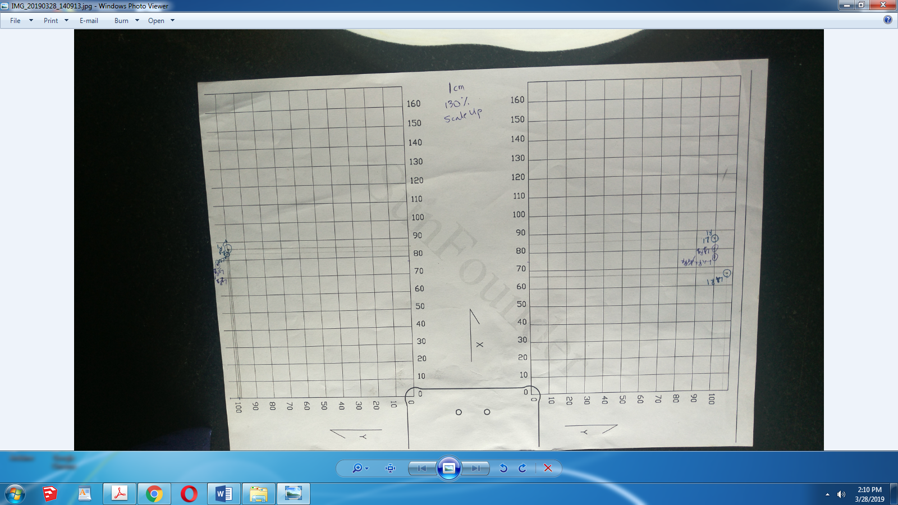

**Image 2.1 Calibration chart**

* 1. **Mechanism**

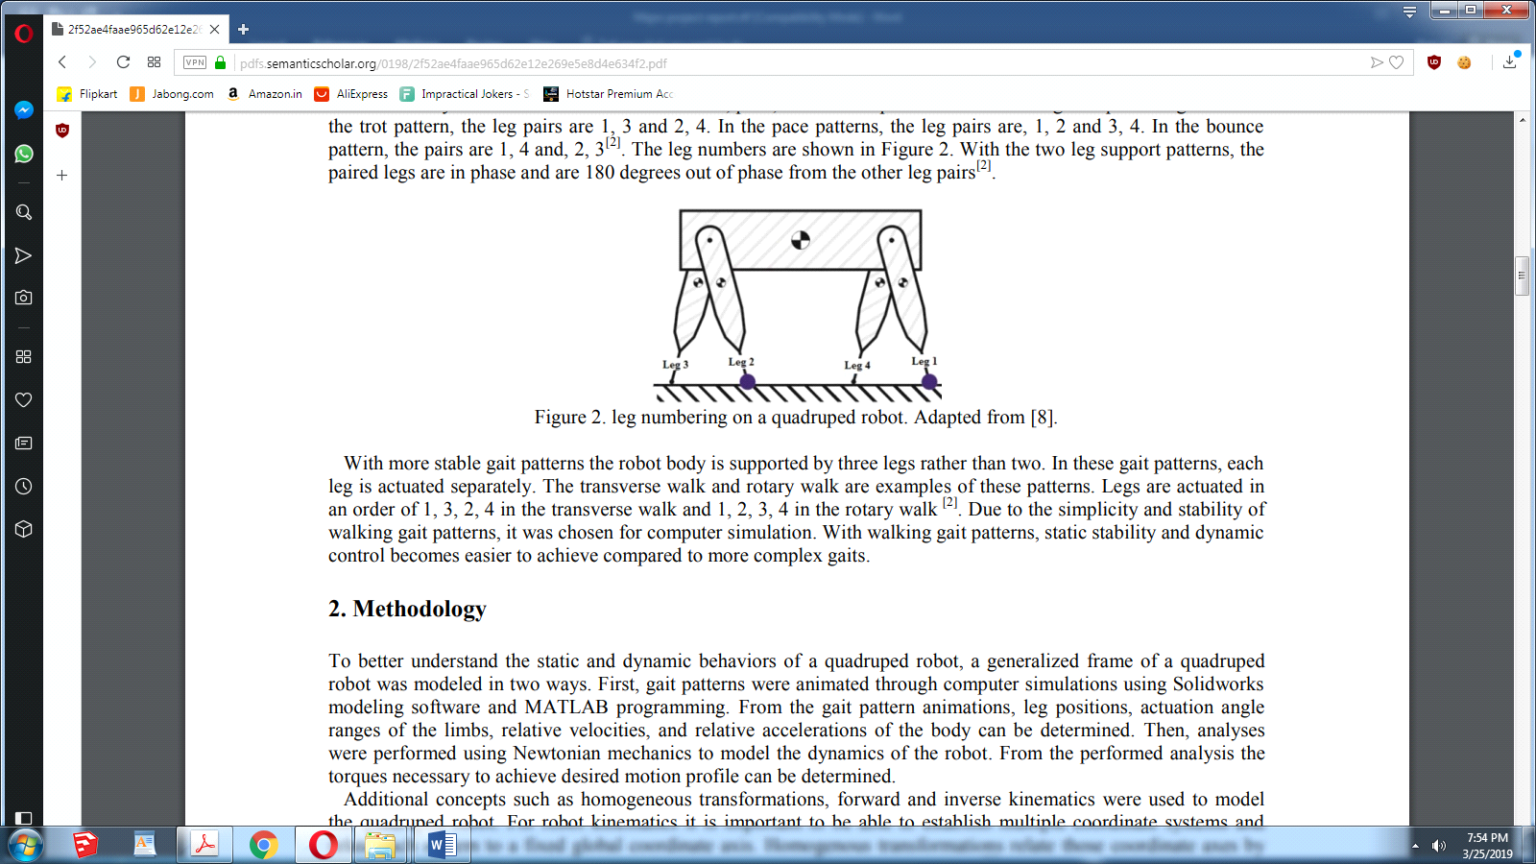

**Fig.2.22. Leg positions**

Another advantage of 4 legged robots is their ability to simulate a wide variety of animal gait patterns. These gait patterns can be categorized into two leg support, and three leg support patterns . The two legged support pattern allows more dynamic movements such as the trot, pace, and bounce patterns where two legs are paired together. For the trot pattern, the leg pairs are 1, 3 and 2, 4. In the pace patterns, the leg pairs are, 1, 2 and 3, 4. In the bounce pattern, the pairs are 1, 4 and, 2, 3 . The leg numbers are shown in Figure 2. With the two leg support patterns, the paired legs are in phase and are 180 degrees out of phase from the other leg pairs . With more stable gait patterns the robot body is supported by three legs rather than two. In these gait patterns, each leg is actuated separately. The transverse walk and rotary walk are examples of these patterns. Legs are actuated in an order of 1, 3, 2, 4 in the transverse walk and 1, 2, 3, 4 in the rotary walk . Due to the simplicity and stability of walking gait patterns, it was chosen for computer simulation. With walking gait patterns, static stability and dynamic control becomes easier to achieve compared to more complex gaits.

* + 1. **The Walking:Creep Gait**

Statically and Dynamically Stable Gaits When the robot walks, it has to keep its balance. There are two general strategies for doing that, and according to them, we divide the gaits into statically stable and dynamically stable. For statically stable gaits it doesn’t matter how fast they are performed, or whether the robot is stopped in a middle of a step – it is stable at any moment, at all times. Animals and people use those gaits when they want to go slowly, or when they want to be able to stop at any time. An example of such a gait is the “creep” gait, used by cats stalking their prey.

Dynamically stable gaits are much harder, as they have to be performed at a particular speed and cannot be interrupted at an arbitrary point. They are sometimes called “controlled falling”, as they exploit thefact that it takes some time for the robot to fall when it’s unstable, and that time can be used to move the legs in such a way as to prevent the fall. Most animal gaits are dynamically stable, as they

The creep gait is the easiest walking gait to use. The robot keeps three feet on the ground, and keeps its center of gravity (CoG) inside the triangle formed by those three feet. If the CoG goes outside this triangle for too long, it will fall over (Figure A).

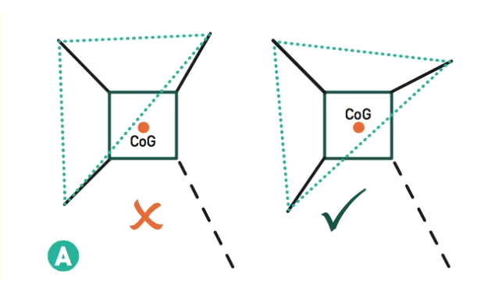

**Fig.2.23. Breaking down the mechanism**

The problem is how to maintain this stability while walking. The pattern in Figure B will save you hours of trial and error. It is a simple type of passively stable creep gait.

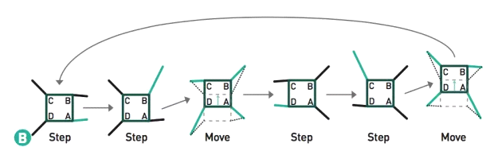

**Fig.2.24. Break Down of the Creep Gait:**

Break Down of the Creep Gait:

1. This is the starting position, with two legs extended out on one side, and the other two legs pulled inward.

2. The top-right leg lifts up and reaches out, far ahead of the robot.

3. All the legs shift backward, moving the body forward.

4. The back-left leg lifts and steps forward alongside the body. This position is the mirror image of the starting position.

5. The top-left leg lifts and reaches out, far ahead of the robot.

6. Again, all the legs shift backward, moving the body forward.

7. The back-right leg lifts and steps back into the body, bringing us back to the starting position.

Notice that at all times, the triangle formed by the legs on the ground contains the CoG. This is the essence of the creep gait.

When we look at this pattern, we can see it is essentially two sets of mirrored movements. Step, step and shift, followed by another step, step and shift on the other side.

* 1. **Fabrication**

**2.3.1 Electric Components**

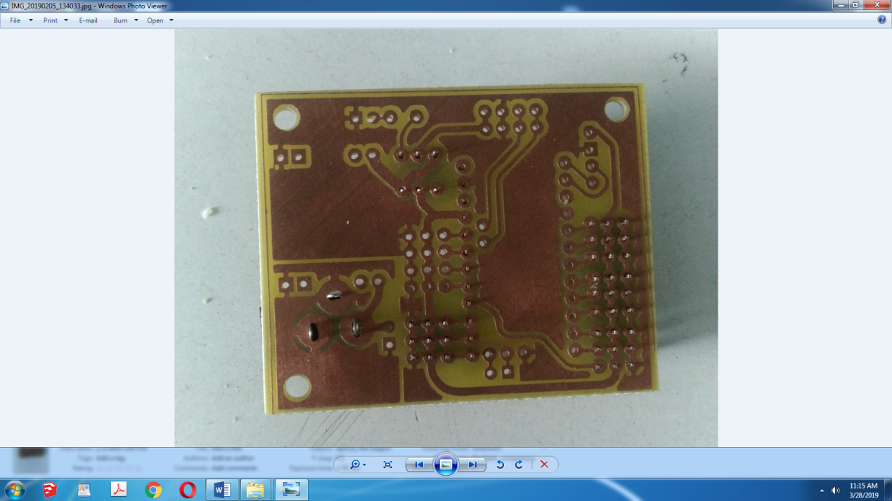

**Image 2.2 PCB**

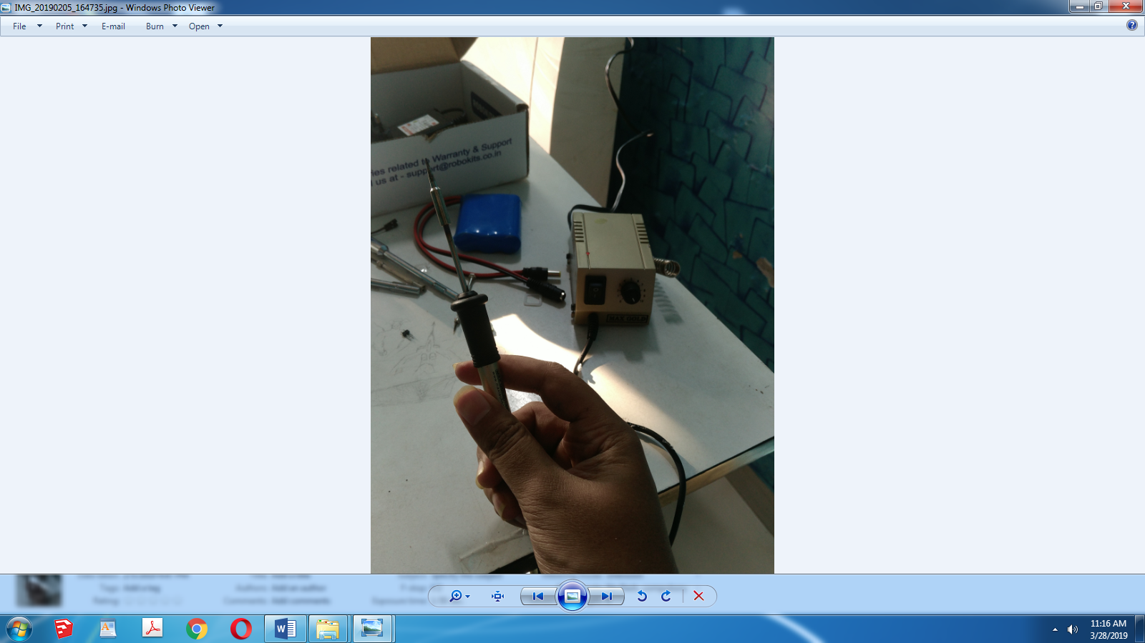

**Image 2.3 12V Mini Solder**

We used a 12V Mini point Solder to solder the compents like Step Down Module,Switch,Pro mini,DC Jack,Servo ports,LED,Resistor to the PCB

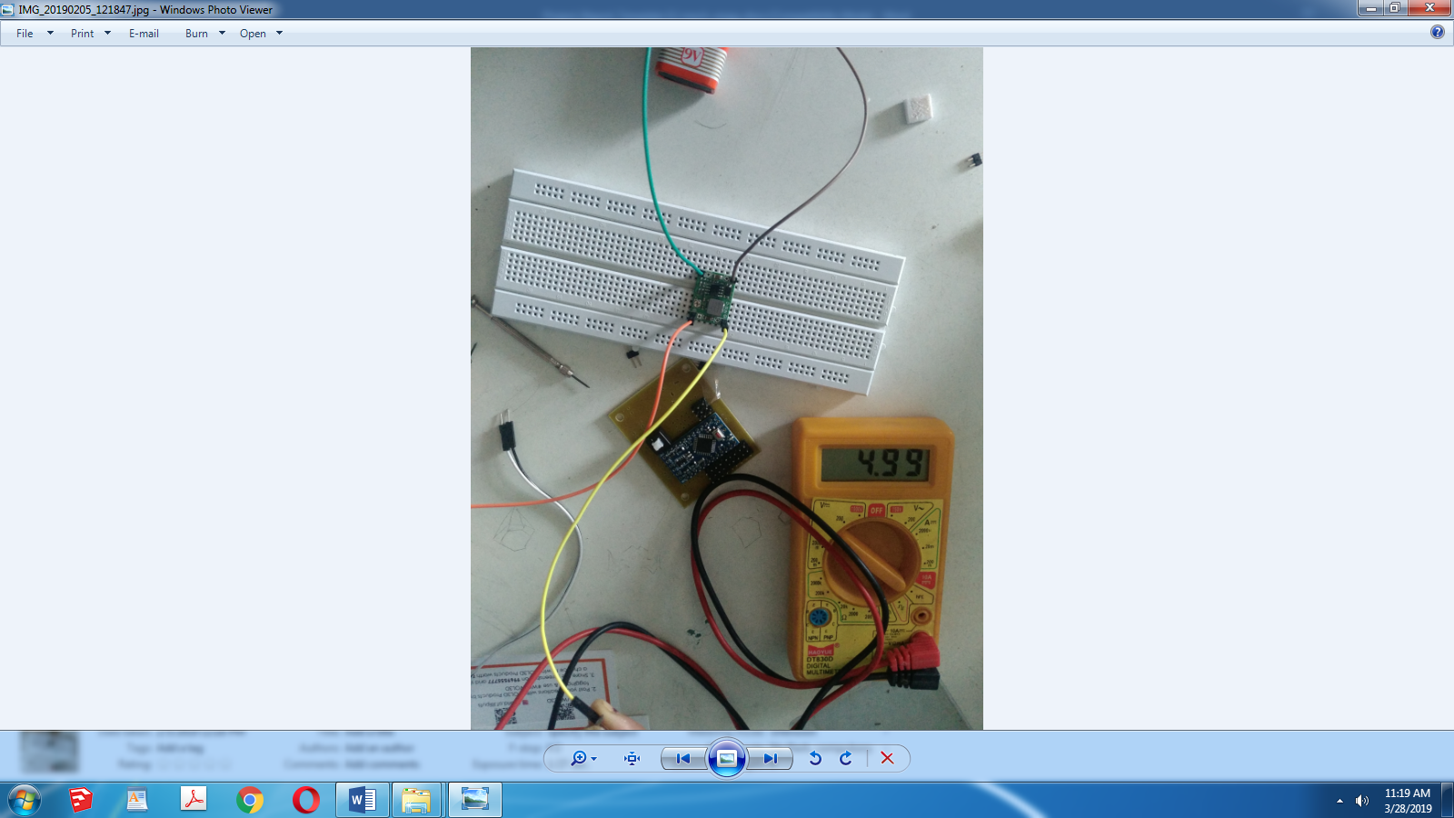

**Image 2.4 Setting LM2596 to 5V output**

Calibration of Step down module using pot to 4.99V by attaching it to 9 V battery

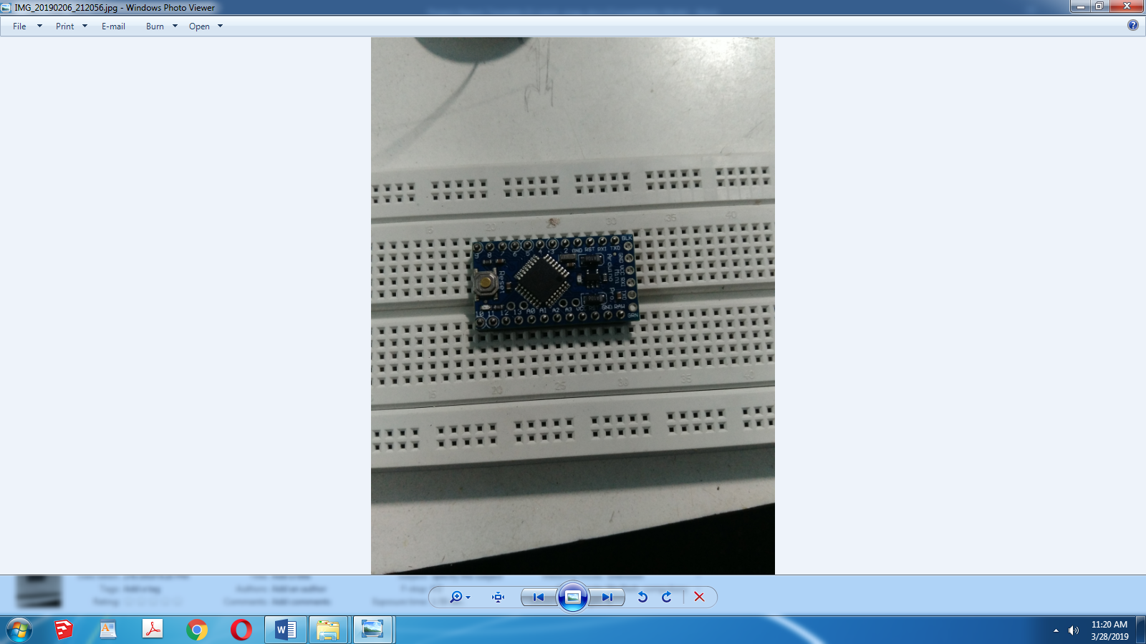

**Image 2.5 Arduino Pro Mini 5V ,16 MHz**

We soldered male pins to compentents rather than directly soldering them to PCB for easy removal and upgradation later on.Above shows a 5V 16MHz Arduino Pro Mini Duplicate Chip with a Reset button.It has 16 pins that can be configured through software to be acted as input or output ports.For the scope of our project they have been kept as output ports(default settings).We have occupied ports 2 to 13 for servo pwm’s.TX and RX for HC-06,GND for common ground and VCC for input of 5V from Step down module.

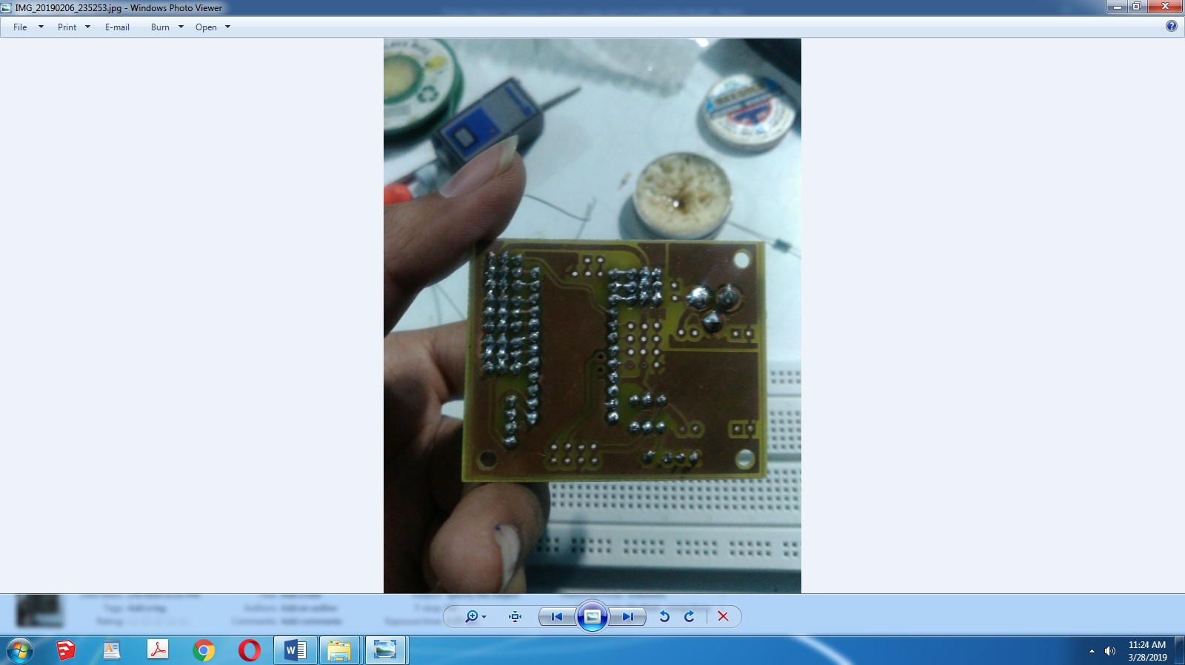

**Image 2.6 PCB after soldering**

PCB’s picture after we soldered all pins.

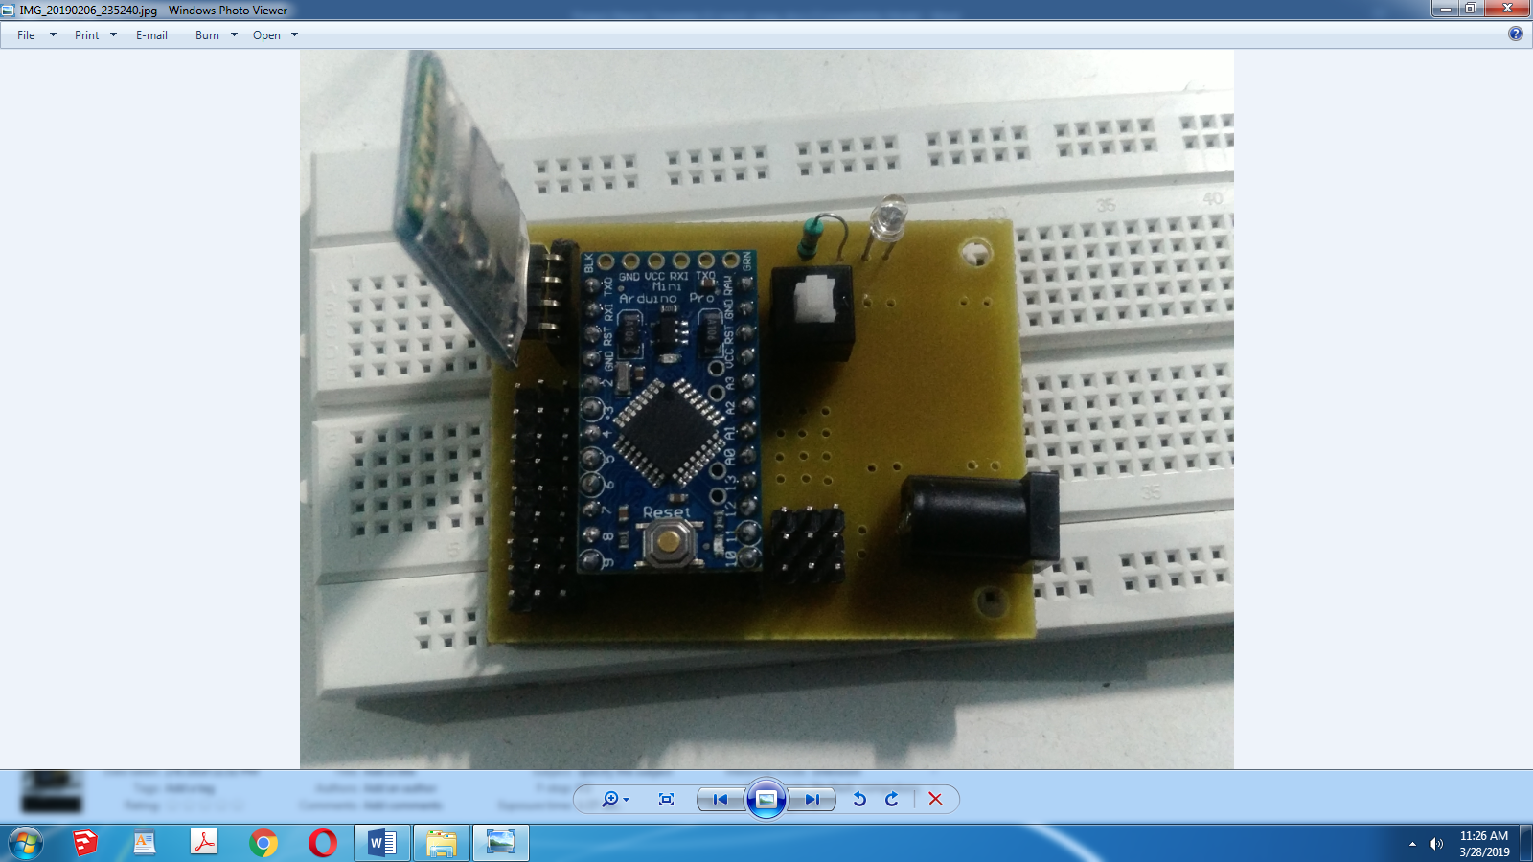

**Image 2.7 Final Electric System**

After mounting all parts via male and female pins.The final board.

**2.3.2 3D Printing**

The printer used is Raise3D’s N2 V2 Hot End.It supports a wide range of printable materials likePLA, ABS, PC, PETG, HIPS, NinjiaFlex.With dual-extruder, you can print with 2 different filaments at the same time. You can make prints with 2 colors or use one filament as the support material to make more complicated models.It has up to 10 micron Z resolution and 12.5 micron X/Y step size to achieve the best print quality and accuracy.It can resume an interrupted print like it never happen!

More Features

A heat bed that can heat up to 110°C

All aluminum metal frame

Build platform is pre-calibrated at the factory

Fully enclosed design for better print quality and improved safety

On-board computer to accommodate future Expansion and experimentation

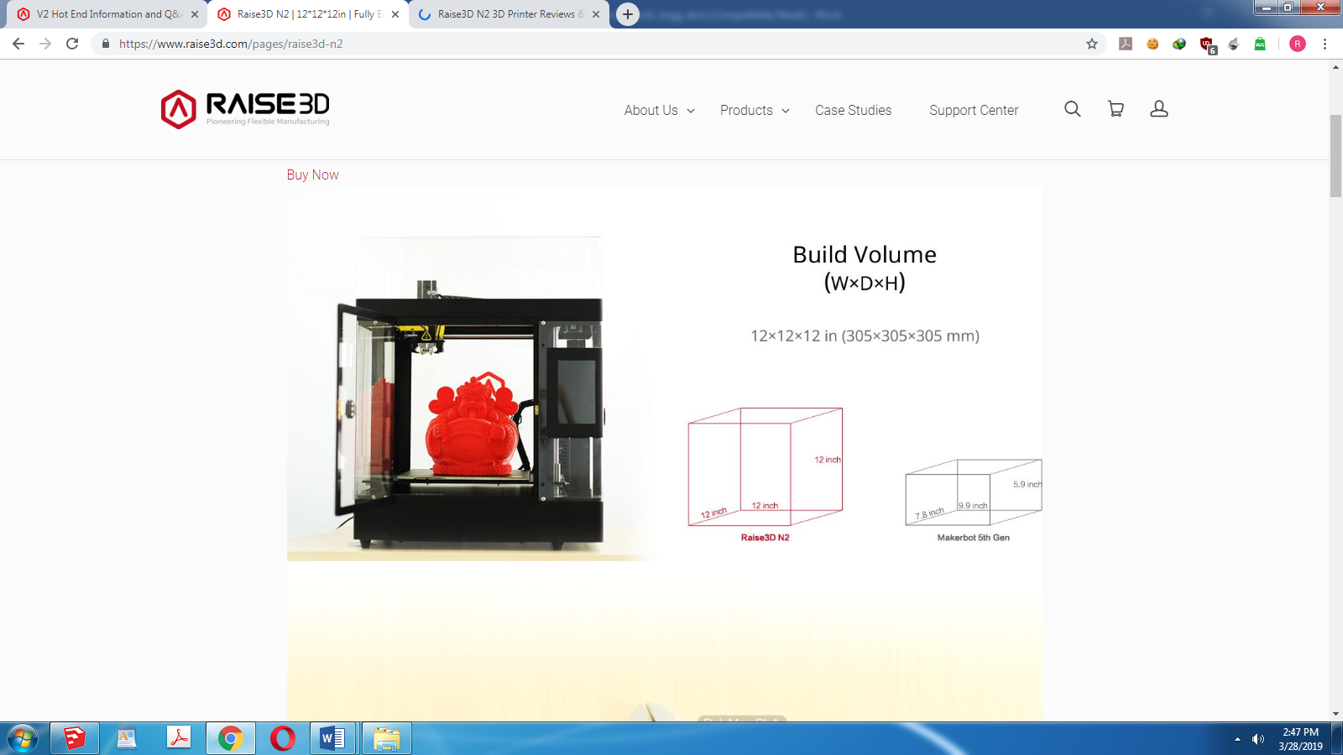

**Image 2.8 Raise3D’s N2 V2 Hot End**

D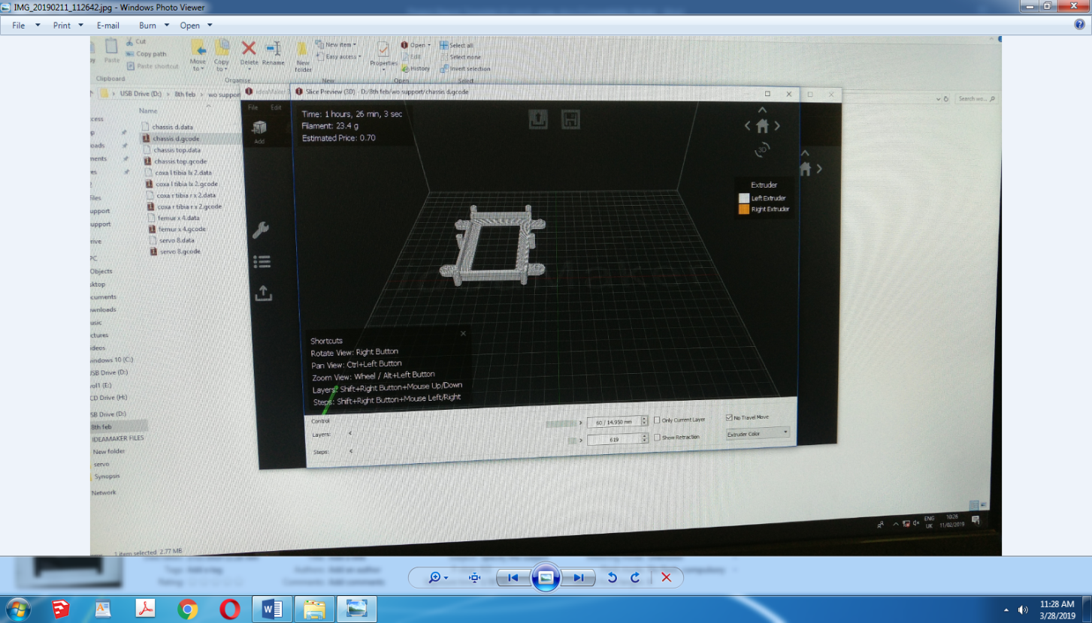

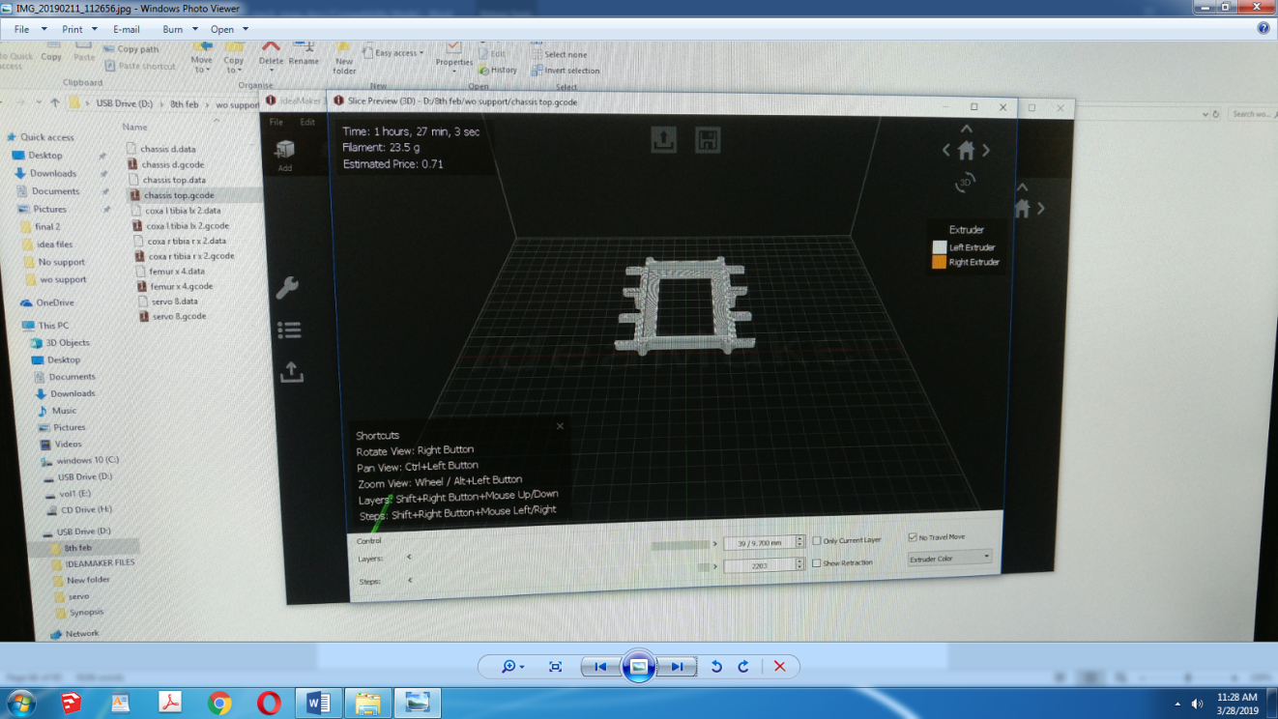

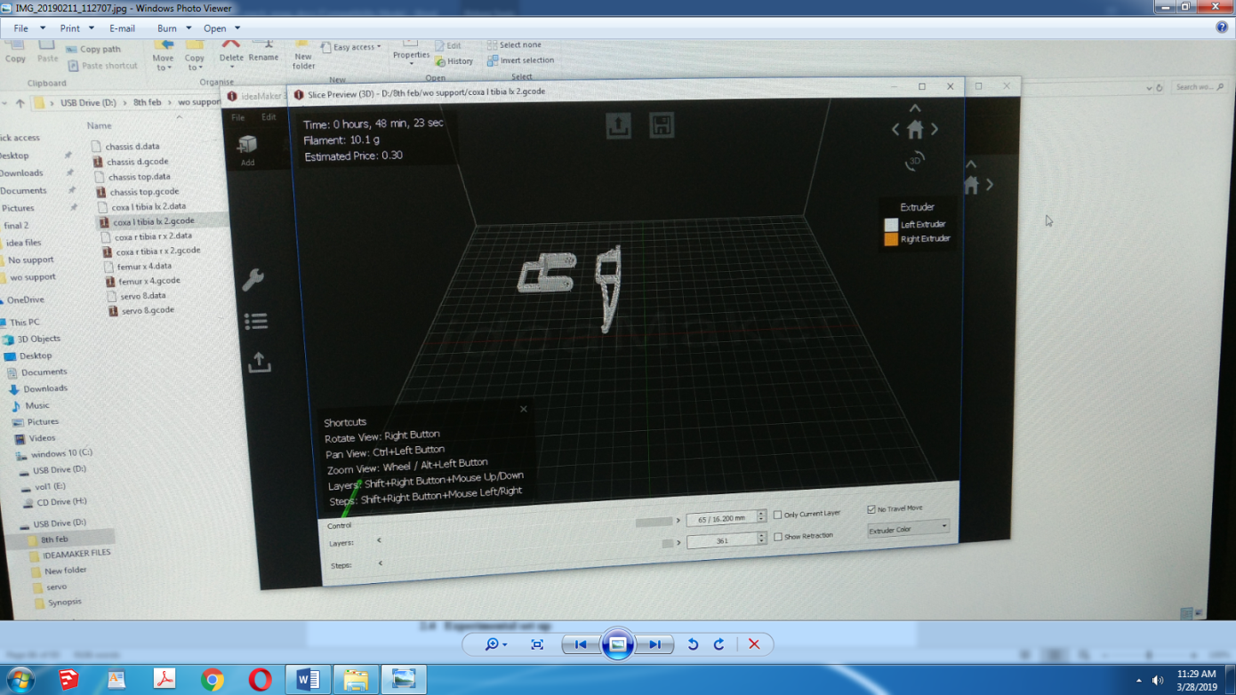

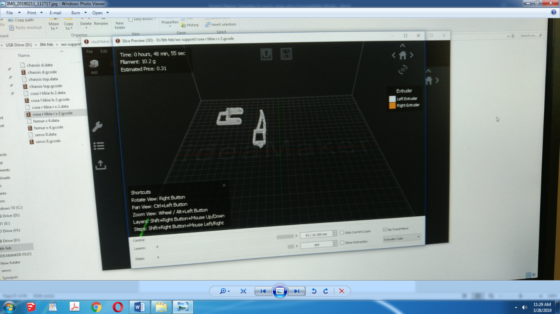

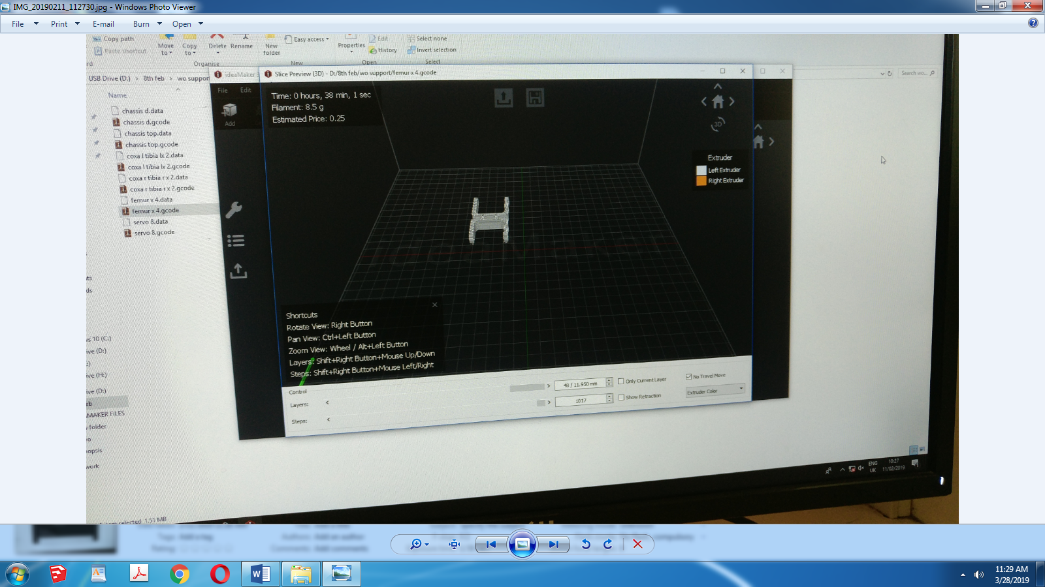

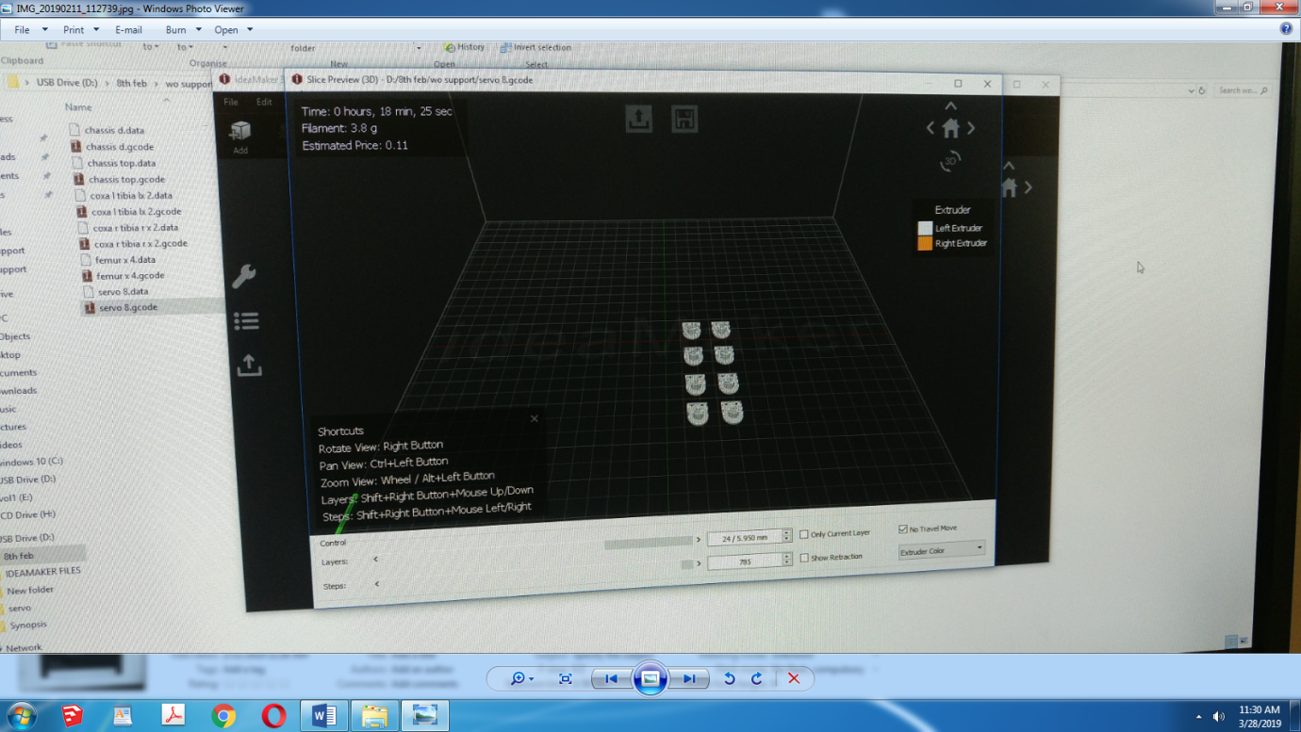

**Image 2.9 3D Settings**

A total of around 9 hours were needed for printing of all parts.The optimal settings of the 3d printer were found out by us after a few trials

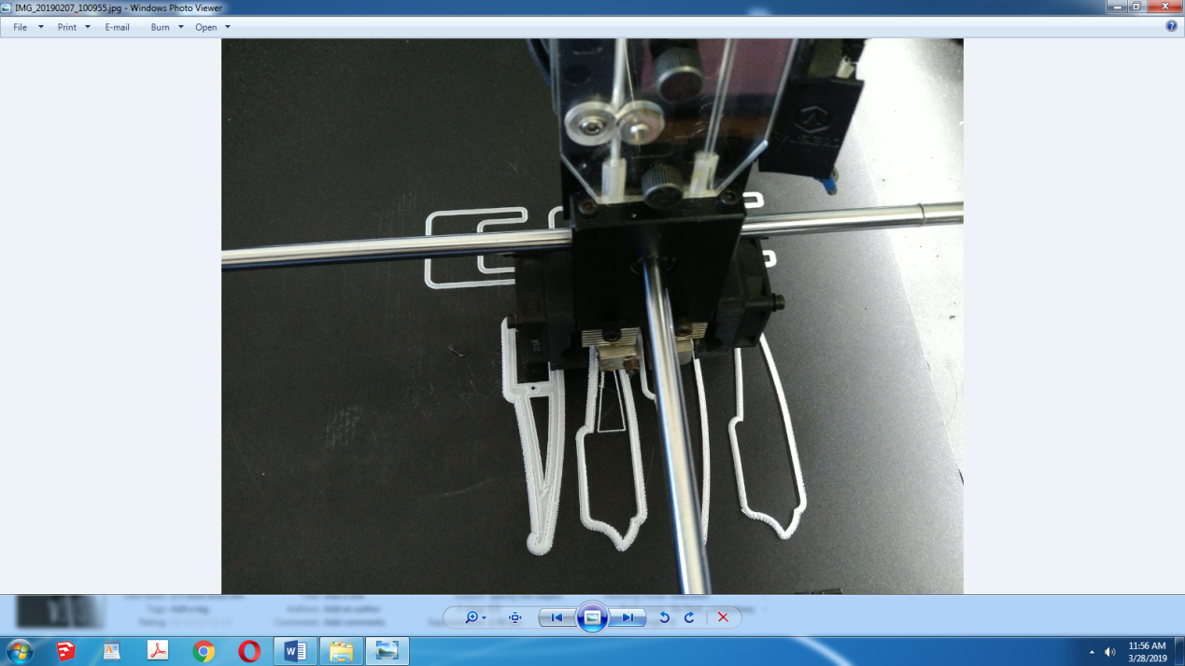

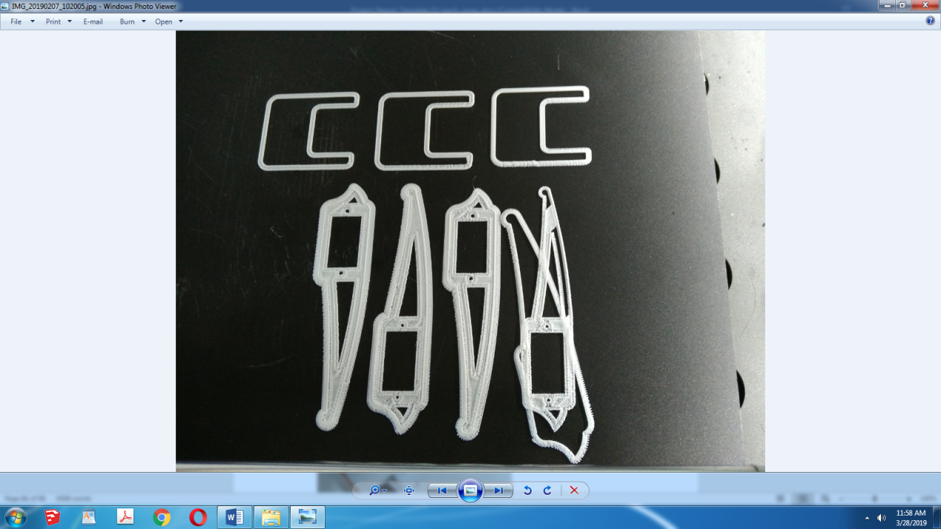

**Image 2.10 Some Errors while printing**

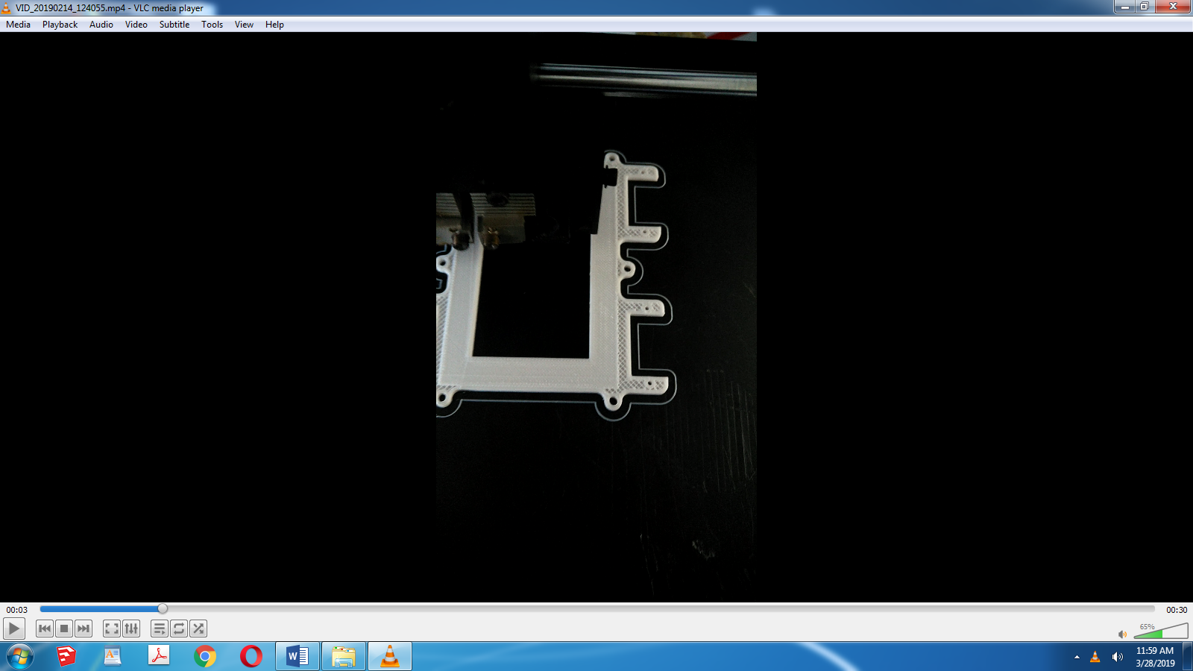

**Image 2.11 Chassis in Print**

Above pictures depicts the infill density settings with hollows in between

.

* + 1. **Finishing Operations**

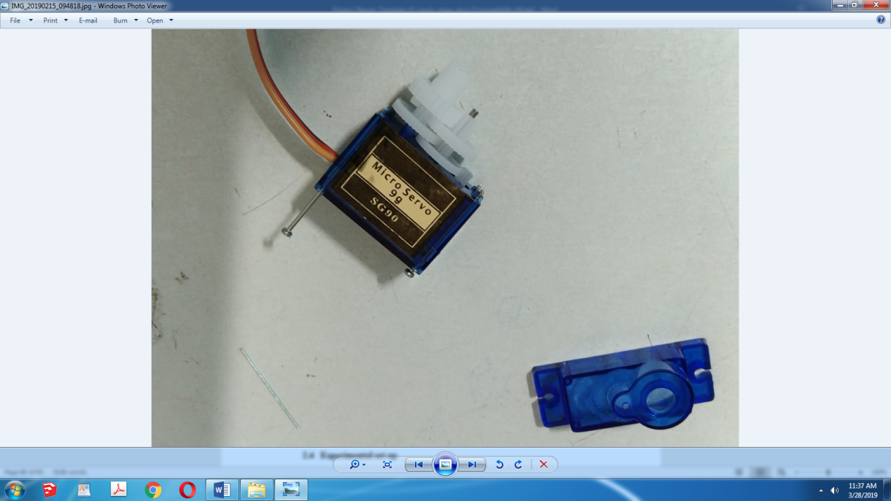

**Image 2.12 Burr Removal in Servo’s Gear Box**

Servo’s internal gears sometimes have nylon-plastic burrs that limit its effective and accurate operation.Thus disassembling and cleaning of gear and greasing them with silicon or petroleum based lubricants.We had to use petroleum jelly Vaseline throughout our lubrication solutions due to nonavailability of silicon based lubricants in Kolhapur.

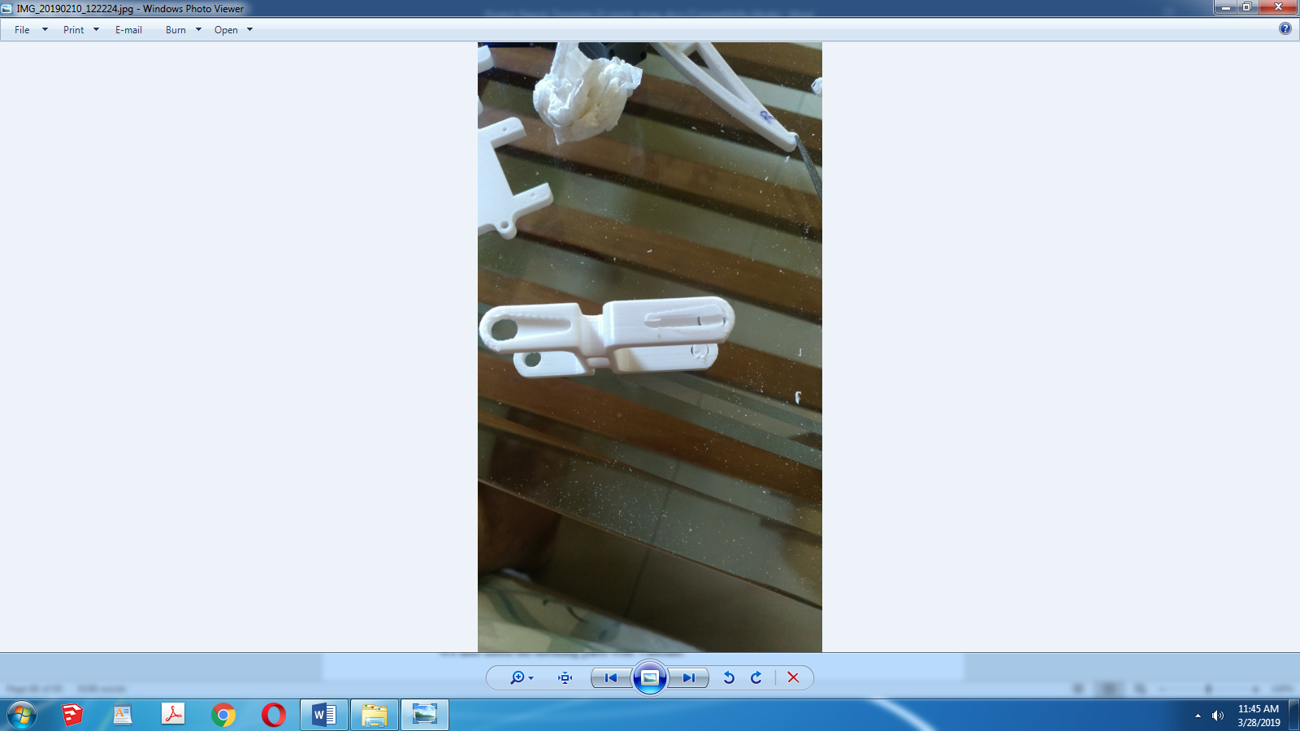

**Image 2.13 Support Removal**

3D printed parts require supports to be printed before actual part is printed at places with cantilevers and hanging parts.these supports are printed at very less density however removing them messes up with parts finish and filing there is very important

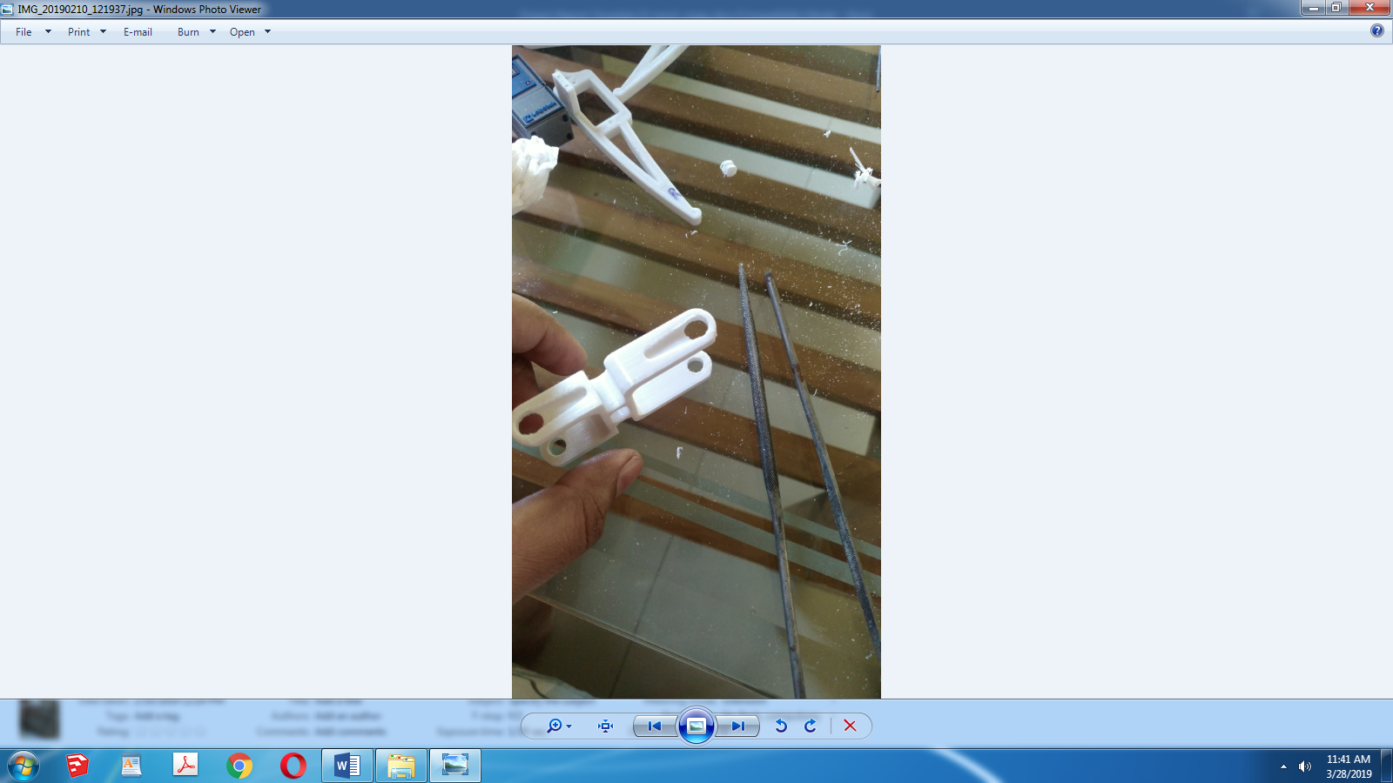

**Image 2.14 Filing Operation**

We also had to file mating parts such as servo holders and their meshing holes with triangular and circular files for smooth and friction less movement between them.this was done arbitarily until acceptably smooth operation was achieved.

We also lubed the meshing parts with Vaseline.

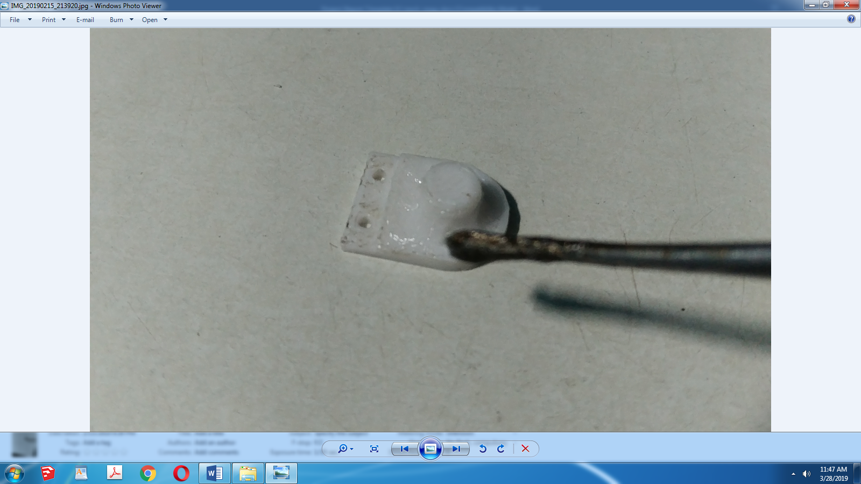

**Image 2.15 Lubricating Meshing Parts**

* 1. **Experimental set up**

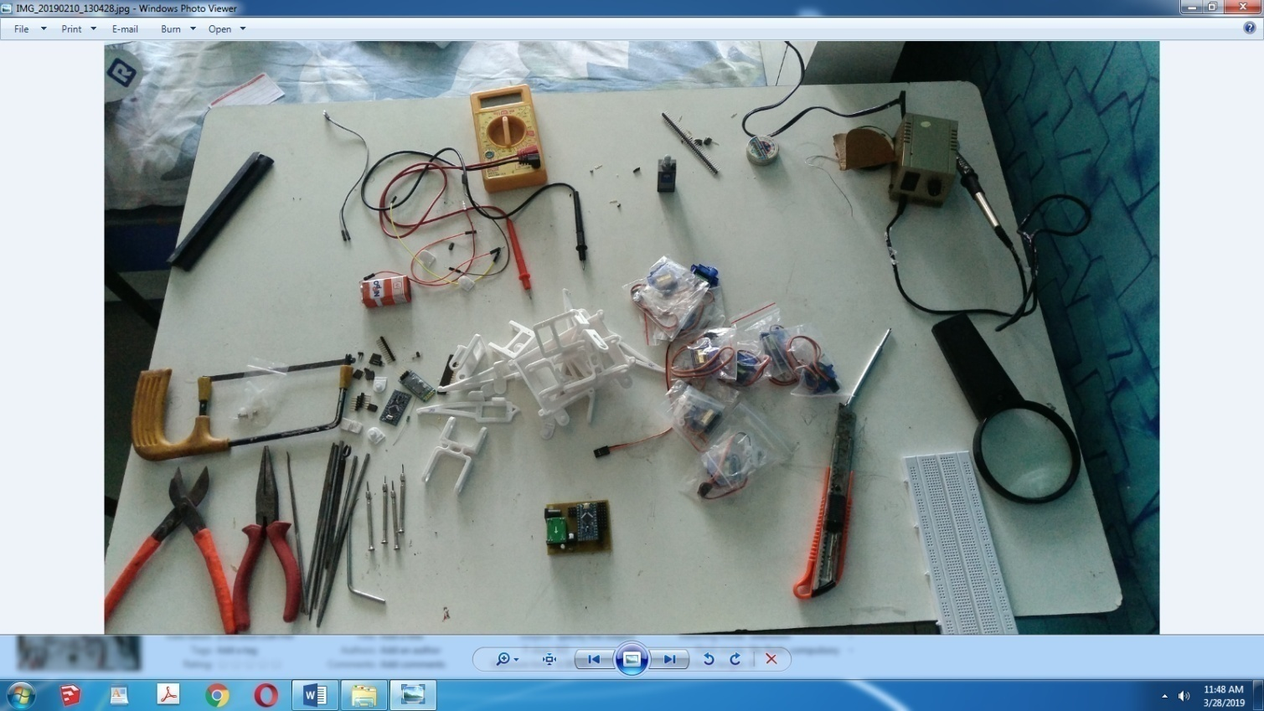

**Image 2.16 Experimental set-up**

Figure shows our homemade Assembly and testing Rig.Experimental Setup includes Multimeter,Ammeter,Cutter,Pliers,Nose plier,Wire plier,Magnifing Glass,Breadboard medium size,Triangular,Circular and semi circular files,Solder gun,Hot gun,50 in 1 mutlidriver set,mini screw driver set,jumper wires of 3 types.

**CHAPTER 3**

# ASSEMBLY AND TESTING

Assembly was mainly done by hand.We used screws of M1.2x3mm and M3x6mm standards throughtout the robot.These screws were difficult to find and we found it in optical shops after what felt like an iternity of searching throughout Kolhapur.

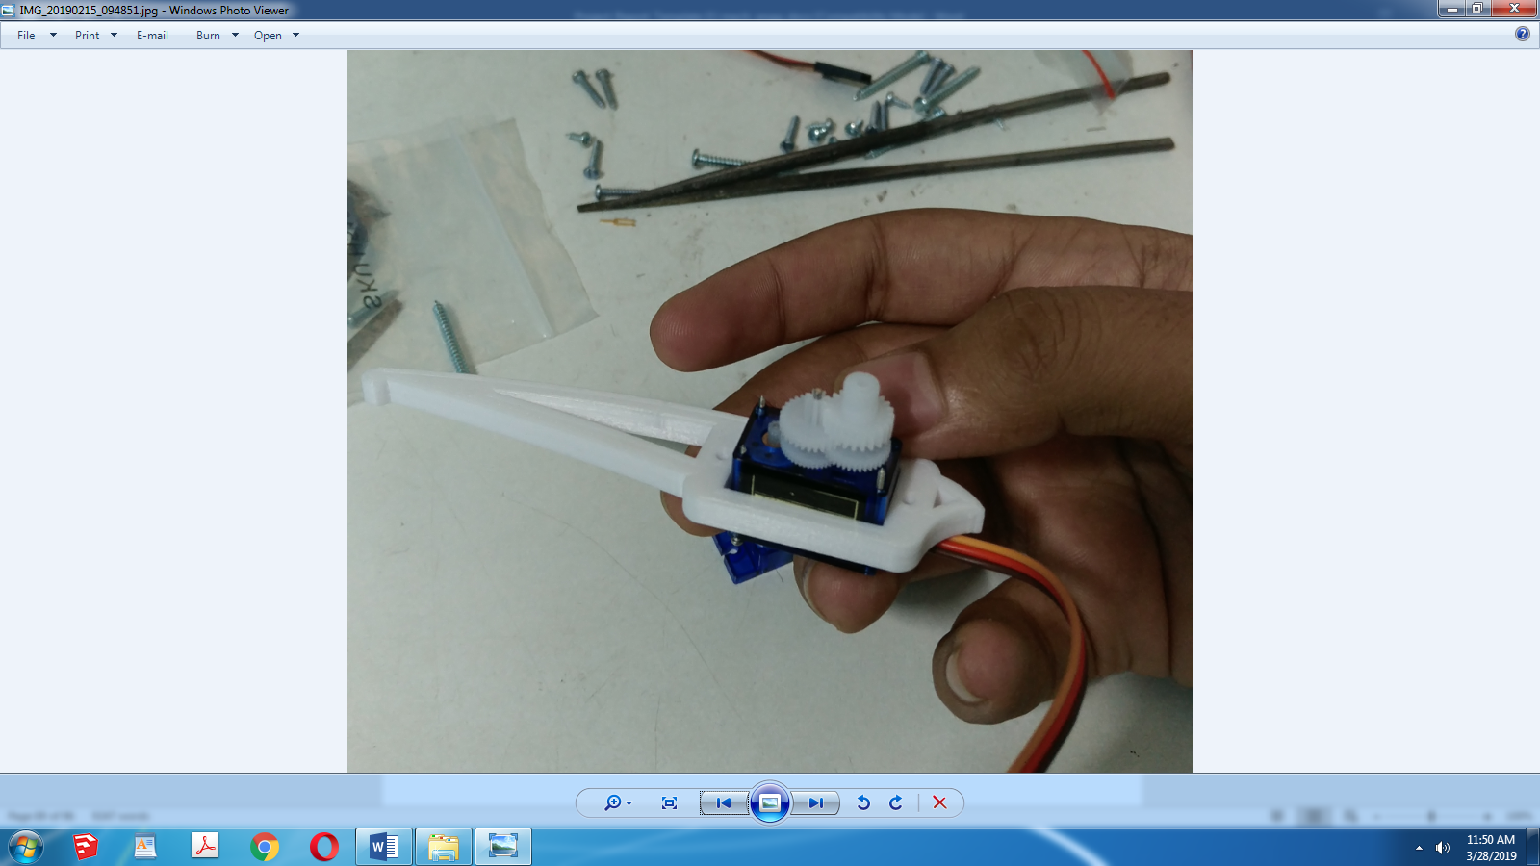

**Image 3.1 Inserting Servos In between Parts**

All parts had servo holdng rectangles.Thus we had to open the servo motors to push them in these rectangles,since we could not do that directly as wires blocked it.

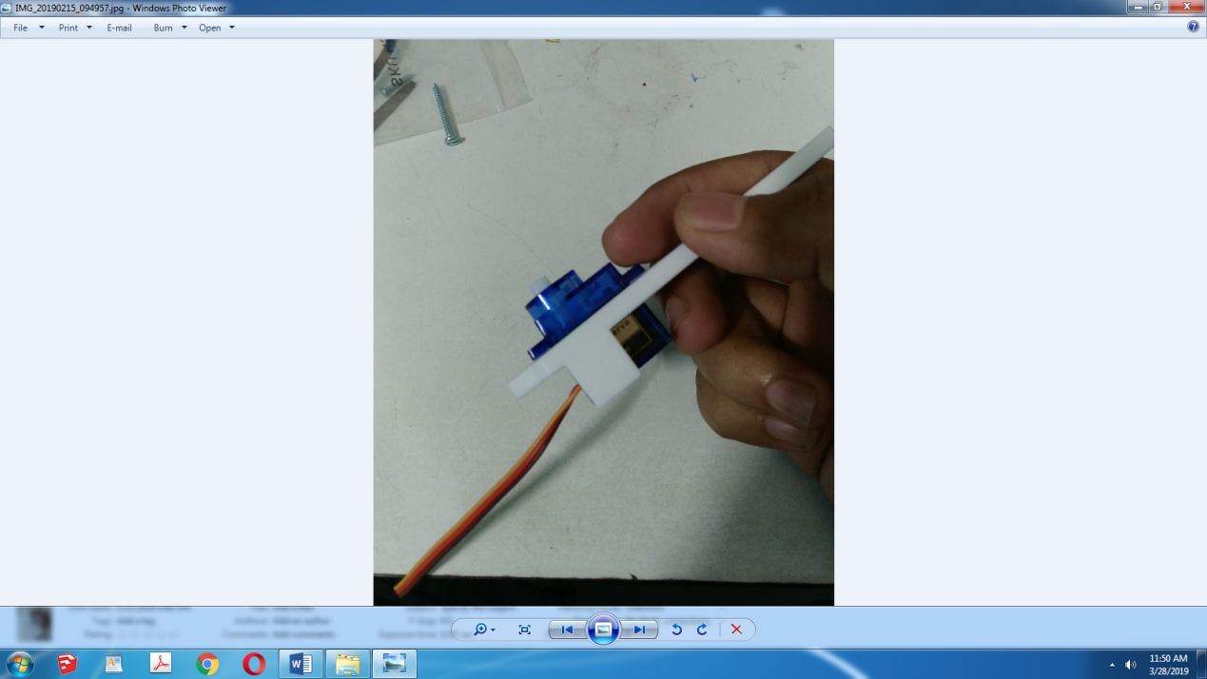

**Image 3.2 After Servo Insertion**

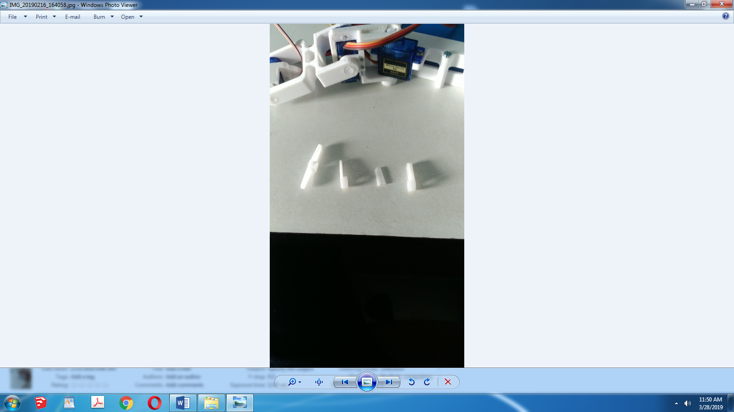

**Image 3.3 Different types of Servo Arm Rockers**

The servo arms shows above.we selected since cantilever servo arm rockers.However after filing we had a new problem that increased the area of this servo arm;more than needed.This caused the arm to not link with the parts and led to slipping of the arms over the respective parts.To tacle this we cut other servo arms as the 3rd peice in above figure and used instant adhensive (fewiquick) to paste it below the 2nd arm in above figure.

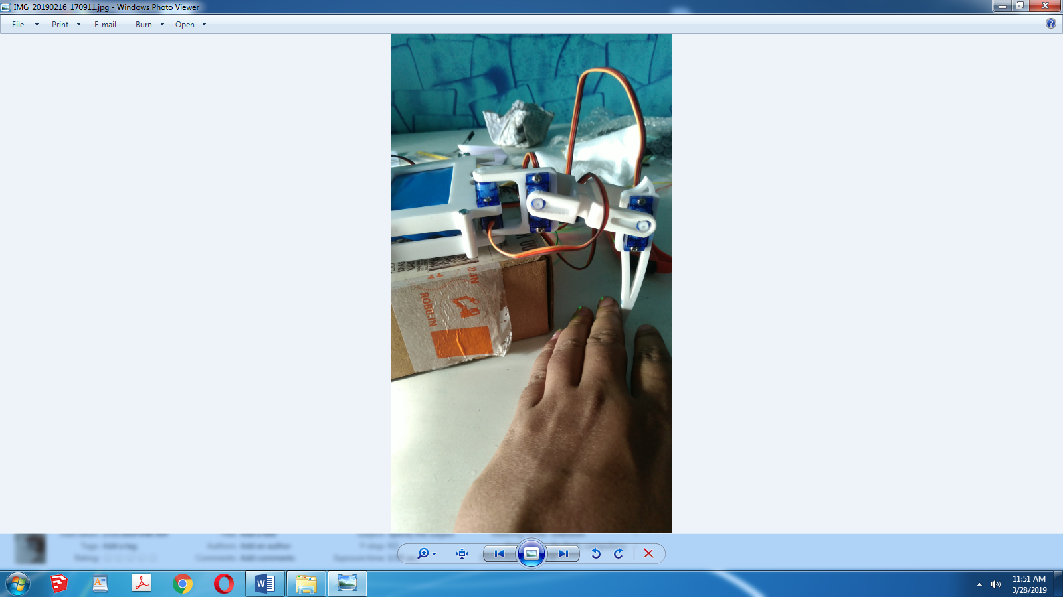

**Image 3.4 Assembly of First Leg**

Assembly and testing of 1 leg is shown above

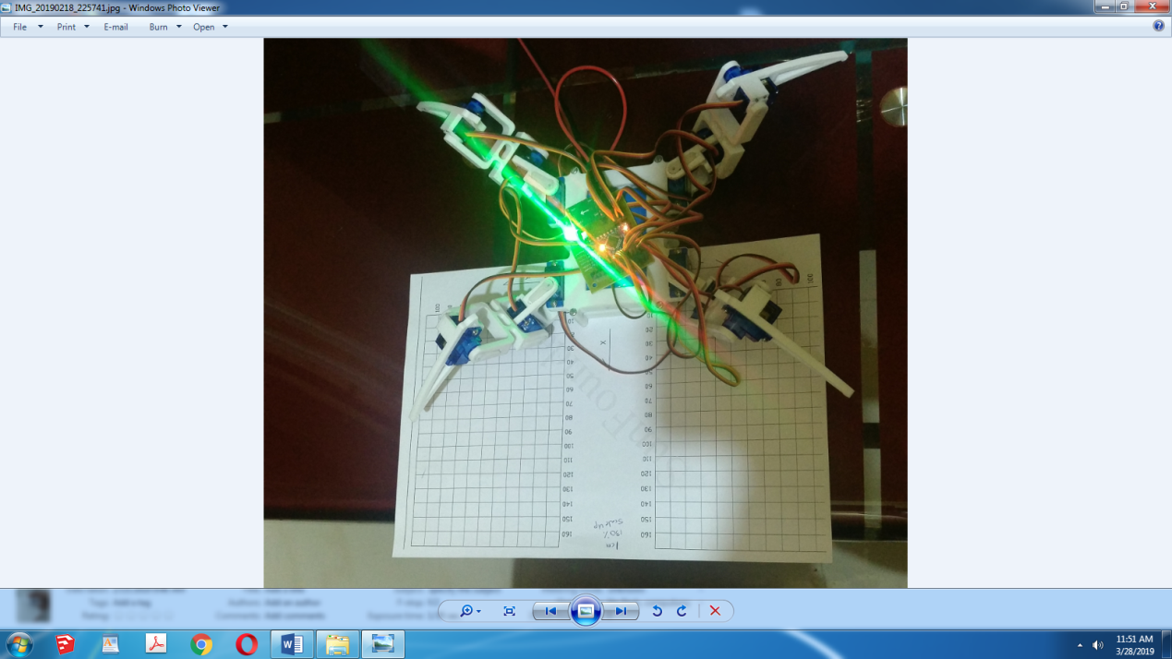

**Image 3.4 Calibration in Process**

Above shows a traditional calibration chart that we ported fro our robot.It features X and Y axis.We position the legs via software to a particular position then measure the X Y And Z axis positions with Vernier Calliper.Then we add the errors to initial positions into codes and redo this proces until error falls below accepted level.We those the eroor to be below 1cm.1 cm is the total error;i.e. summation of all 3 errors should be below 1 cm.

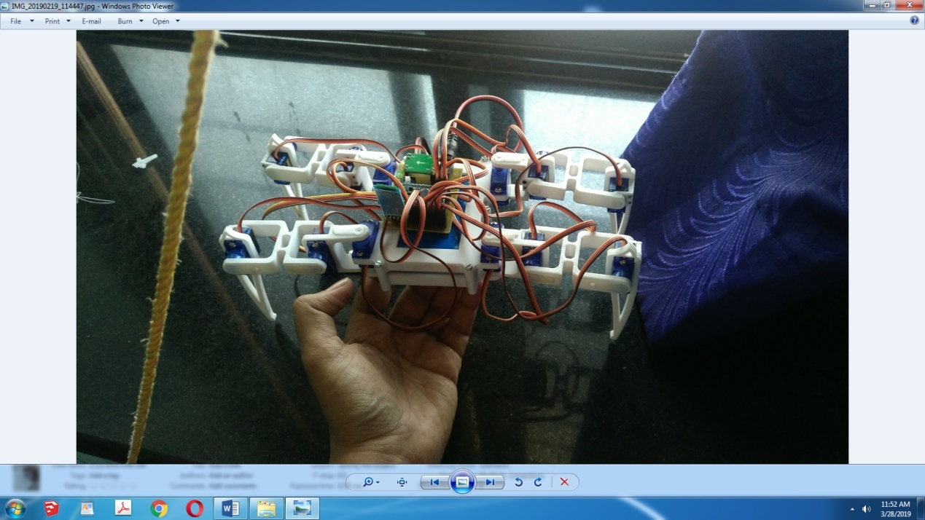

**Image 3.7 Calibration Position**

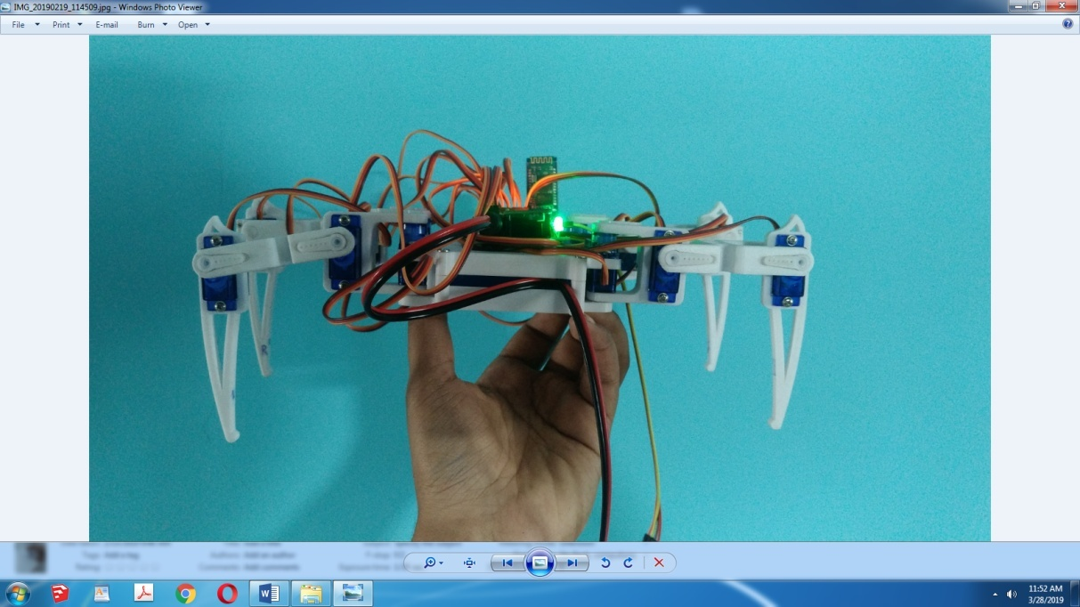

**Image 3.8 Calibrated Position**

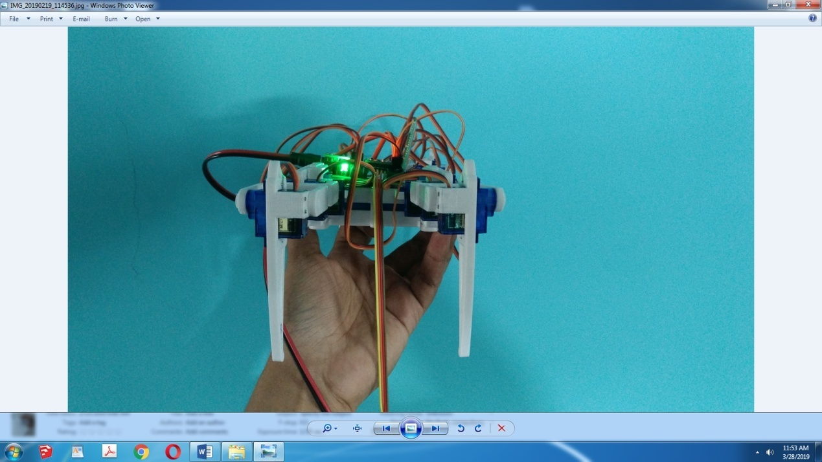

**Image 3.9 Right Hand Side View**

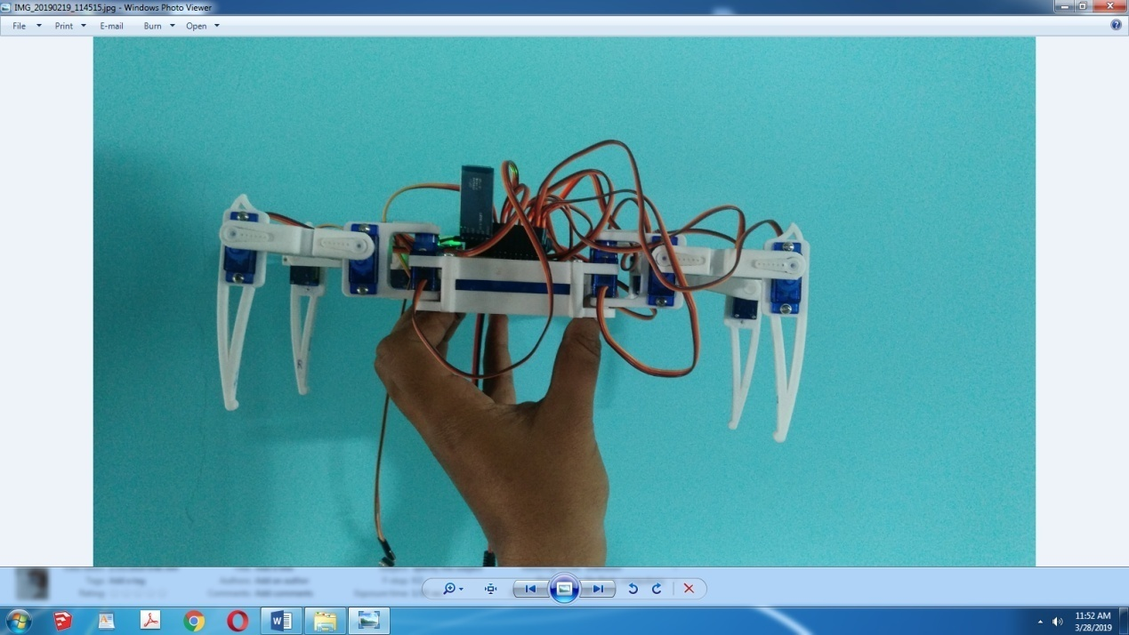

**Image 3.10 Bottom Hand Side View**

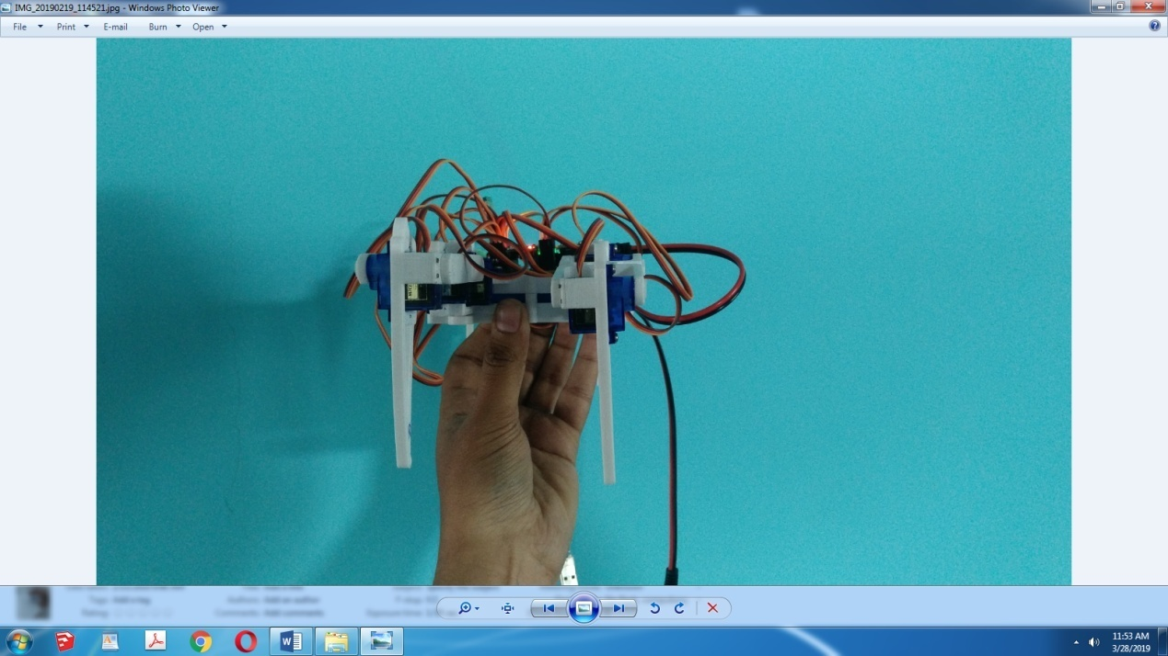

**Image 3.11 Left Hand Side View**

Above Pictures show how much initial locations for each leg had to be changed from the designed 90 degree positions to tackle the problem of limited accuracy of fabrication of the 3D printer.

**CHAPTER 4**

# RESULTS AND DISCUSSION

1. **Results**

We found out how much difference in design and actual product had.The robot walks with a heavy whinning that points our inconsistency in torques of individual servos.The gait has been an outstanding sucess.We sucessfully occupied 30kb of total 32 kb of processor memory.The machine has been loaded fully,even above designed.This design has been utilised to its fullest.The program is compact enough for the processor to process it without lag,owning to al agfree control of robot.

* 1. **Limitations**

1Mechanical Design

The way this robot is assembled together only works because it’s so lightweight. Would the robot be heavier, there would be significant problems:Servomotors are used as structural elements.The printed circuit board is also used as a structural element.The whole robot weight rests sideways on the servo shafts.The servo horns used for legs are elastic

Electrical Design

The desire to cut costs and minimise the number of parts also made us make some not-entirely-genuine decisions on the electrical side of things:The servomechanisms are under powered. The specification asks for 6V, and they get 5V from servo driver which draws power from Li-Ion battery.The servomechanisms are powered from the board directly.There is no battery charger build in.

Computational design

No further improvement in code can be done without changing the processor as almost all memmory has been utilised.This limits our design to no use of sensors,partly due to elctric power constraints of processor and partly due to lack of storage space.

**CHAPTER 5**

# CONCLUSIONS

1. Conclusion

Today we find most robots working for people in industries, factories, ware houses and laboratories. Robots are useful in many ways. For instance, boosts economy because businesses need to be humanless, e.g.robot can build, assemble a car. yet robots cannot perform every job, today robot's roles include assisting research and industry .Finally ,as technology improves, there will be new ways to use robots which will bring new hopes and new potentials. The advantages are both physiological and practical it would be easier to interact with a machine that looks and acts as human. The main practical advantage is that a legged robot would be able to move and work in the human environment without need for its modification. A possible humanoid's creation might need thorough analysis of human-like characteristics of a humanoid : human-like motion, human-like intelligence, human-like communication. Such a challenging goal requires co-ordinated and integrated research efforts that span over wide range of disciplines such a system theory, control theory, artificial intelligence, material science, mechanics, and even bio mechanics and neuroscience. Thus the research is difficult, but the target is challenging and promising. Our opinion that result achieved in the domain of human-like motion or still rather limited, while in the domain of human-like communication several viable alternatives have been produced.

However, Human like walking is the main obstacle to be overcome because of its complexity and multi dimensionality.An early solution to humanoid design may be a quad legged design,equipped with artificial intelligence.This tries to counter the massive expenses involved in a humanoid's mechanical design aspect.Thus what our project tries is create is 'A VESSEL FOR THE SOUL OF ARTIFICIAL INTELLIGENCE OF TOMMOROW'!

**5.2 Future scope**

Since this robot is so simple, it is very easy to modify or extend it. You can add sensors and peripherals, or control it remotely from another computer or directly with another microcontroller or microcomputer board. The possibilities are infinite, as long as the board in question has a serial or I²C interface, can be powered from a single LiPo or Li Ion battery, and doesn’t weight too much for the robot to carry it.

If your board or module can be powered with 5V, simply use the FTDI header of your Pro Mini for connecting it – it has broken out the power and serial interface. You will have to write the code for communicating with the board yourself.

Usage of multiple such robots for surveillance or mapping of terrains is also possible and a promising field to start with this would be Swarm Robotics.Alternatedly we can traint he robot using Machine learning for it to be able to span rough terrains.Using infrared sensores can help it to detect obstacles.A LCD display can also be used in order to display useful information or simply give the robot a VUI.

Upgrading the processor with higher version can also facilitate Artificial Intelligence someday,and that is the future we are working with today!

# 

# REFERENCES

1. Gait Planning and Stability Control of a Quadruped Robot Junmin Li,1 Jinge Wang,1 Simon X. Yang,2 Kedong Zhou,1 and Huijuan Tang1
2. Kevin Lee, The Mathematical Model and Computer Simulation of a Quadruped Robot, Research Experience for Undergraduates 2014, Milwaukee School of Engineering, National Science Foundation Grant. (2014)
3. Zhao Tang, Peng Qi, Jian Dai, (2017) "Mechanism design of a biomimetic quadruped robot", Industrial Robot: An International Journal, Vol. 44 Issue: 4, doi: 10.1108/IR-11-2016-0310
4. Marc Raibert, Kevin Blankespoor, Gabriel Nelson, Rob Playter and the BigDog Team, BigDog, the Rough –Terrain Quadruped Robot, Proceedings of the 17th World Congress The International Federation of Automatic Control Seoul, Korea, July 6 -11, 2008
5. S. Shoval, E. Rimon and A. Shapiro, "Design of a spider -like robot for motion with quasi -static force constraints," Proceedings 1999 IEEE International Conference on Robotics and Automation, Detroit, MI, 1999, pp. 1377 -1383 vol.2. doi: 10.1109/ROBOT.1999.772553
6. Yi Lu, Keke Zhou, Nijia Ye, Design andm kinemics/dynamics analysis of a novel climbing robot with tri - planar limbs for remanufacturing, Journal of Mechanical, Science and Technology, March 2017, Volume 31, Issue 3, pp 1427 –1436
7. Claudio Semini, HyQ - Design and Development of a Hydraulically Actuated Quadruped Robot, A thesis submittedn for the degree of Doctor of Philosophy (Ph.D.) April 2010.
8. Hongbo Wang, Zhengyan Qi, Guiling Xu, Fengfeng Xi, nGuoqing Hu and Zhen Huang, Kinematics Analysis and nMotion Simulation of a QuadrupedWalking Robot withn Parallel Leg Mechanism, The Open Mechanical EngineeringJournal, 2010, 4, 77 n-85
9. Garabini M., Santina C.D., Bianchi M., Catalano M., nGrioli G., Bicchi A. (2017) Soft Robots that Mimic the Neuromusculoskeletal System. In: Ibáñez J., González -Vargas nJ., Azorín J., Akay M., Pons J. (eds) Converging Clinical and Engineering Research on Neurorehabilitation II. Biosystems & Biorobotics, vol 15. Springer, Cham